Circular Arrangement

Definition
# Source: AI Source: Provided by: [Data Path: Persons Table -> ID Column: 1, Name_En Column: Motasem Essam] -> From: [ChatGPT] on [7/25/2026]
A Circular Arrangement is a type of composite solid arrangement in which two or more solid components are positioned around a common center, following a circular path or pattern.
The components are typically distributed at different angular positions along an imaginary circle. They may be equally spaced or unevenly distributed, and they may surround an empty central region or a central solid component.
A circular arrangement can be constructed using cubes, rectangular prisms, cylinders, cones, pyramids, or mixed geometric solids.

Simple Definition
# Source: AI Source: Provided by: [Data Path: Persons Table -> ID Column: 1, Name_En Column: Motasem Essam] -> From: [ChatGPT] on [7/25/2026]
A circular arrangement is a composite solid in which multiple components are positioned around a common center along a circular pattern.

Geometric Representation
# Source: AI Source: Provided by: [Data Path: Persons Table -> ID Column: 1, Name_En Column: Motasem Essam] -> From: [ChatGPT] on [7/25/2026]
A circular arrangement is commonly represented by placing repeated solid components around a central point or axis.
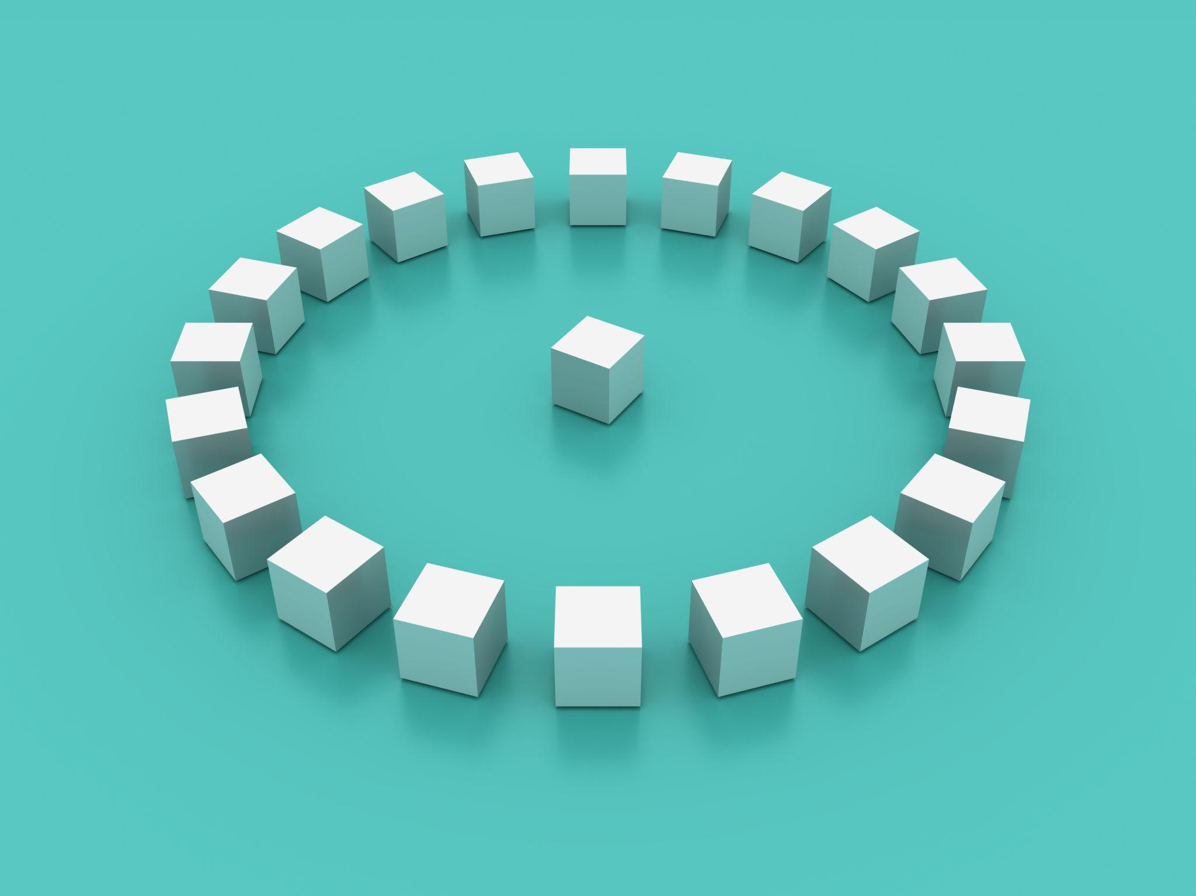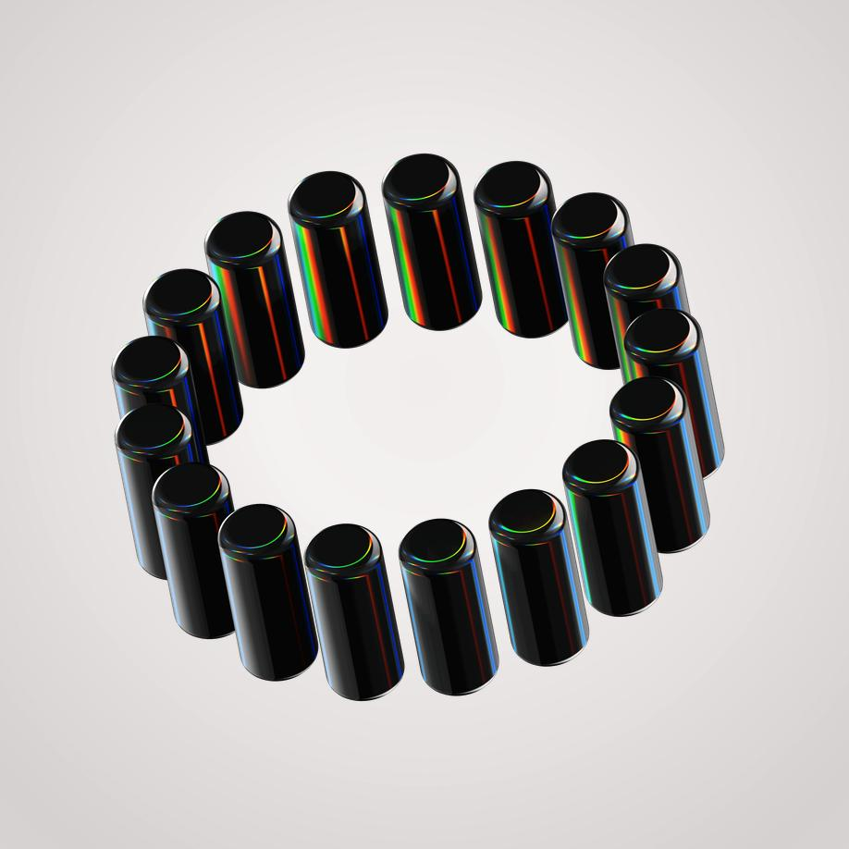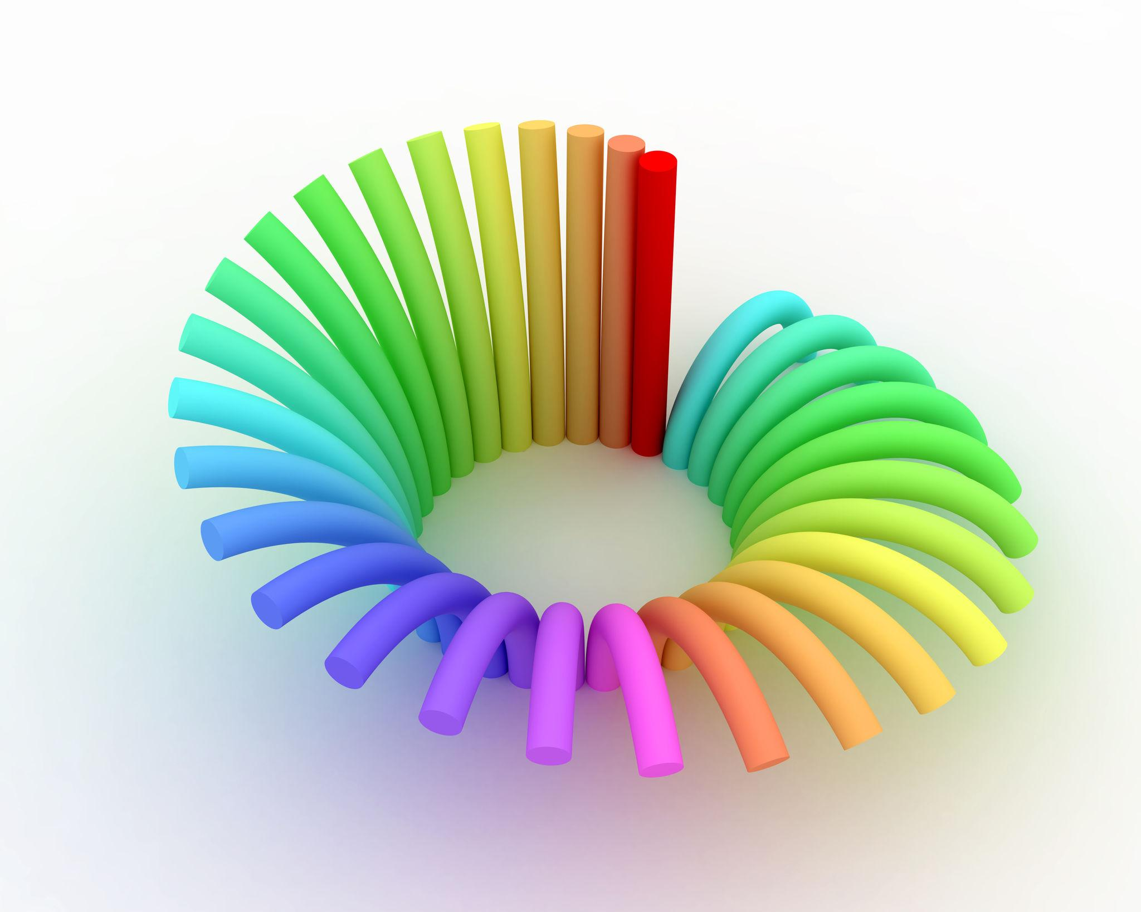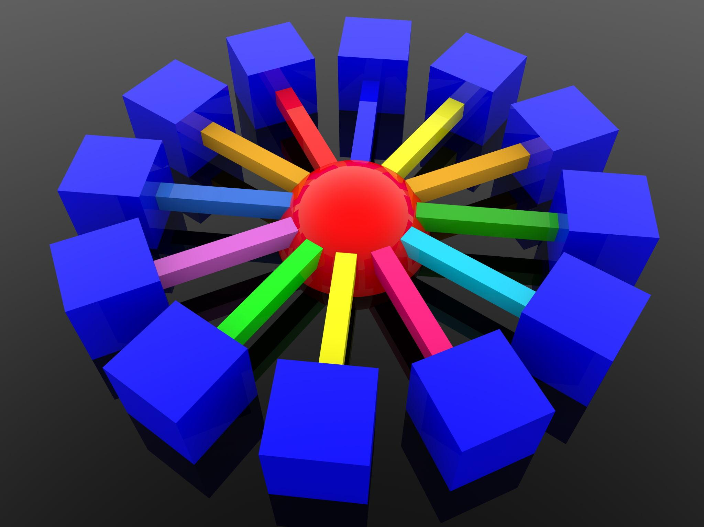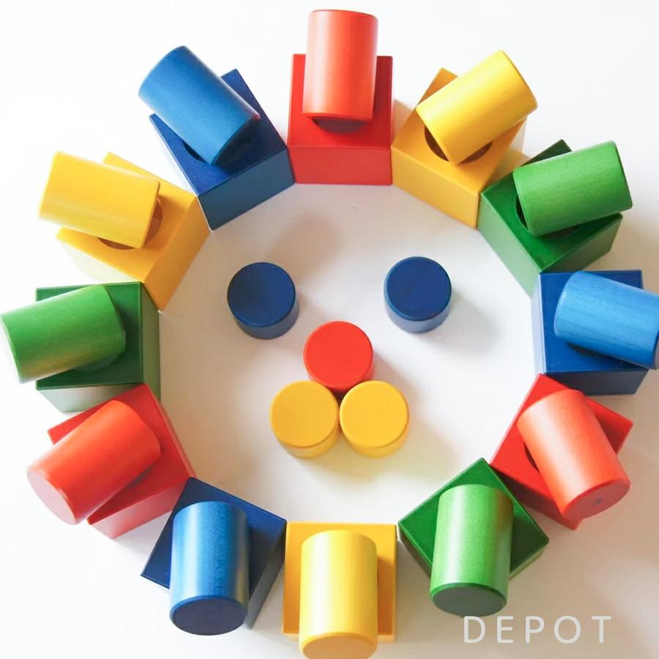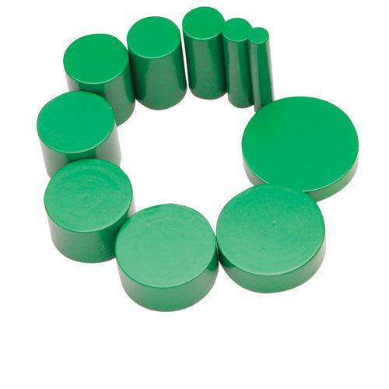
Main geometric elements:
- Center: The common reference point of the circular arrangement.
- Circular Path: The imaginary circular path along which the components are distributed.
- Radius of Arrangement: The distance from the center to the reference point of each component.
- Central Region: The space or central solid surrounded by the components.
- Angular Position: The angular location of each component relative to a reference direction.
- Angular Separation: The angle between consecutive component positions.
- Circumference: The length of the circular path.

Main Classification
# Source: AI Source: Provided by: [Data Path: Persons Table -> ID Column: 1, Name_En Column: Motasem Essam] -> From: [ChatGPT] on [7/25/2026]
Circular arrangements can be classified according to angular distribution, number of circular rows, central configuration, component dimensions, and geometric shape.

Classification by Angular Distribution
# Source: AI Source: Provided by: [Data Path: Persons Table -> ID Column: 1, Name_En Column: Motasem Essam] -> From: [ChatGPT] on [7/25/2026]
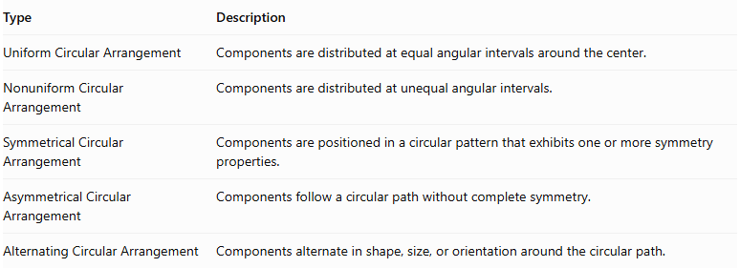
Type | Description
Uniform Circular Arrangement | Components are distributed at equal angular intervals around the center.
Nonuniform Circular Arrangement | Components are distributed at unequal angular intervals.
Symmetrical Circular Arrangement | Components are positioned in a circular pattern that exhibits one or more symmetry properties.
Asymmetrical Circular Arrangement | Components follow a circular path without complete symmetry.
Alternating Circular Arrangement | Components alternate in shape, size, or orientation around the circular path.
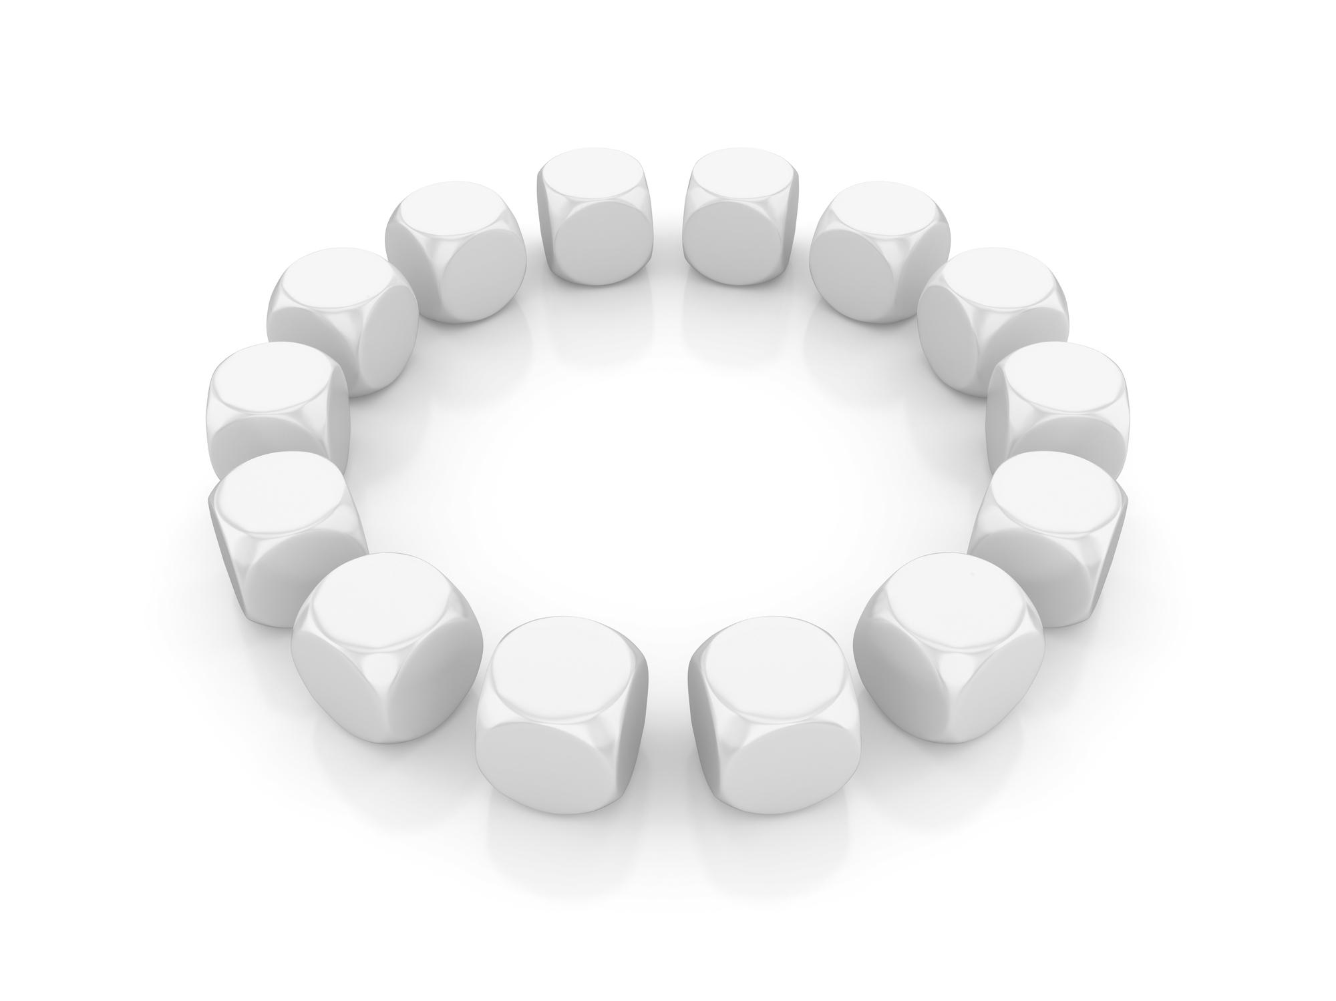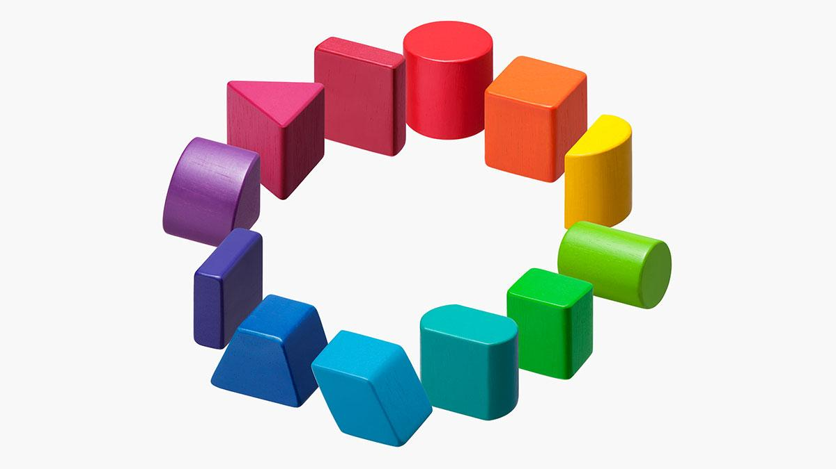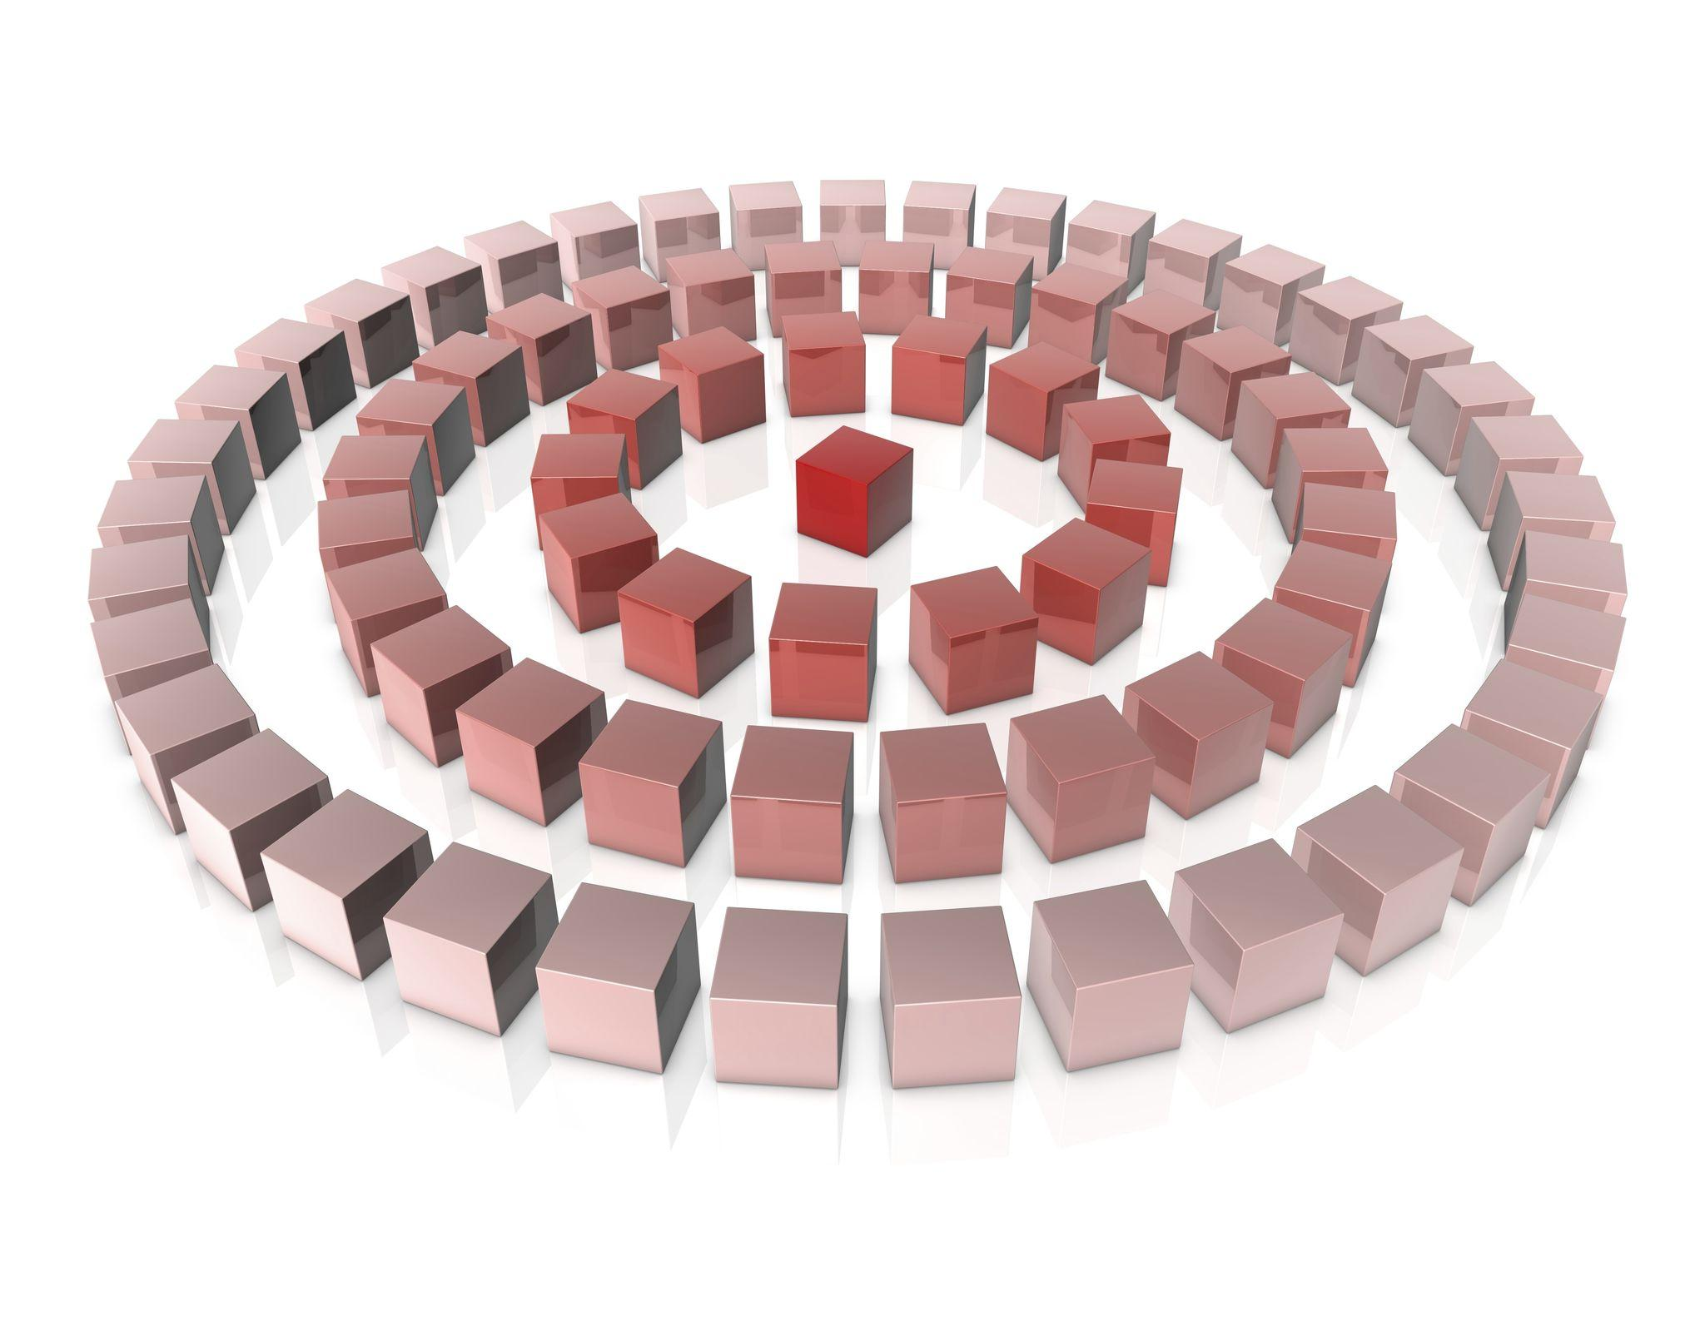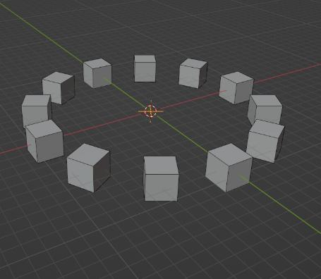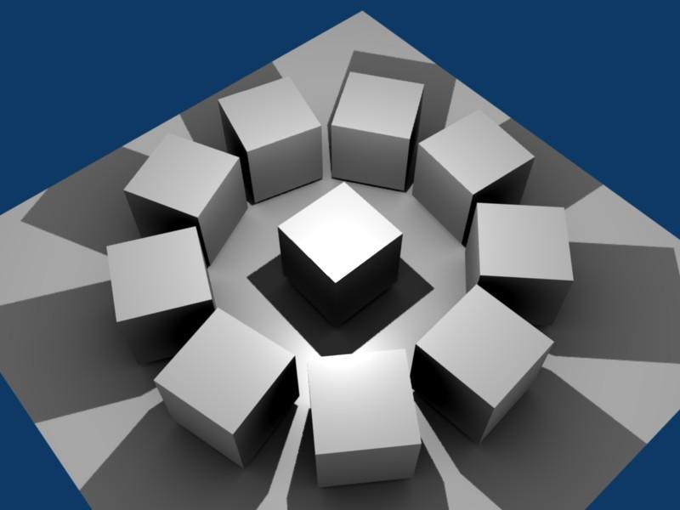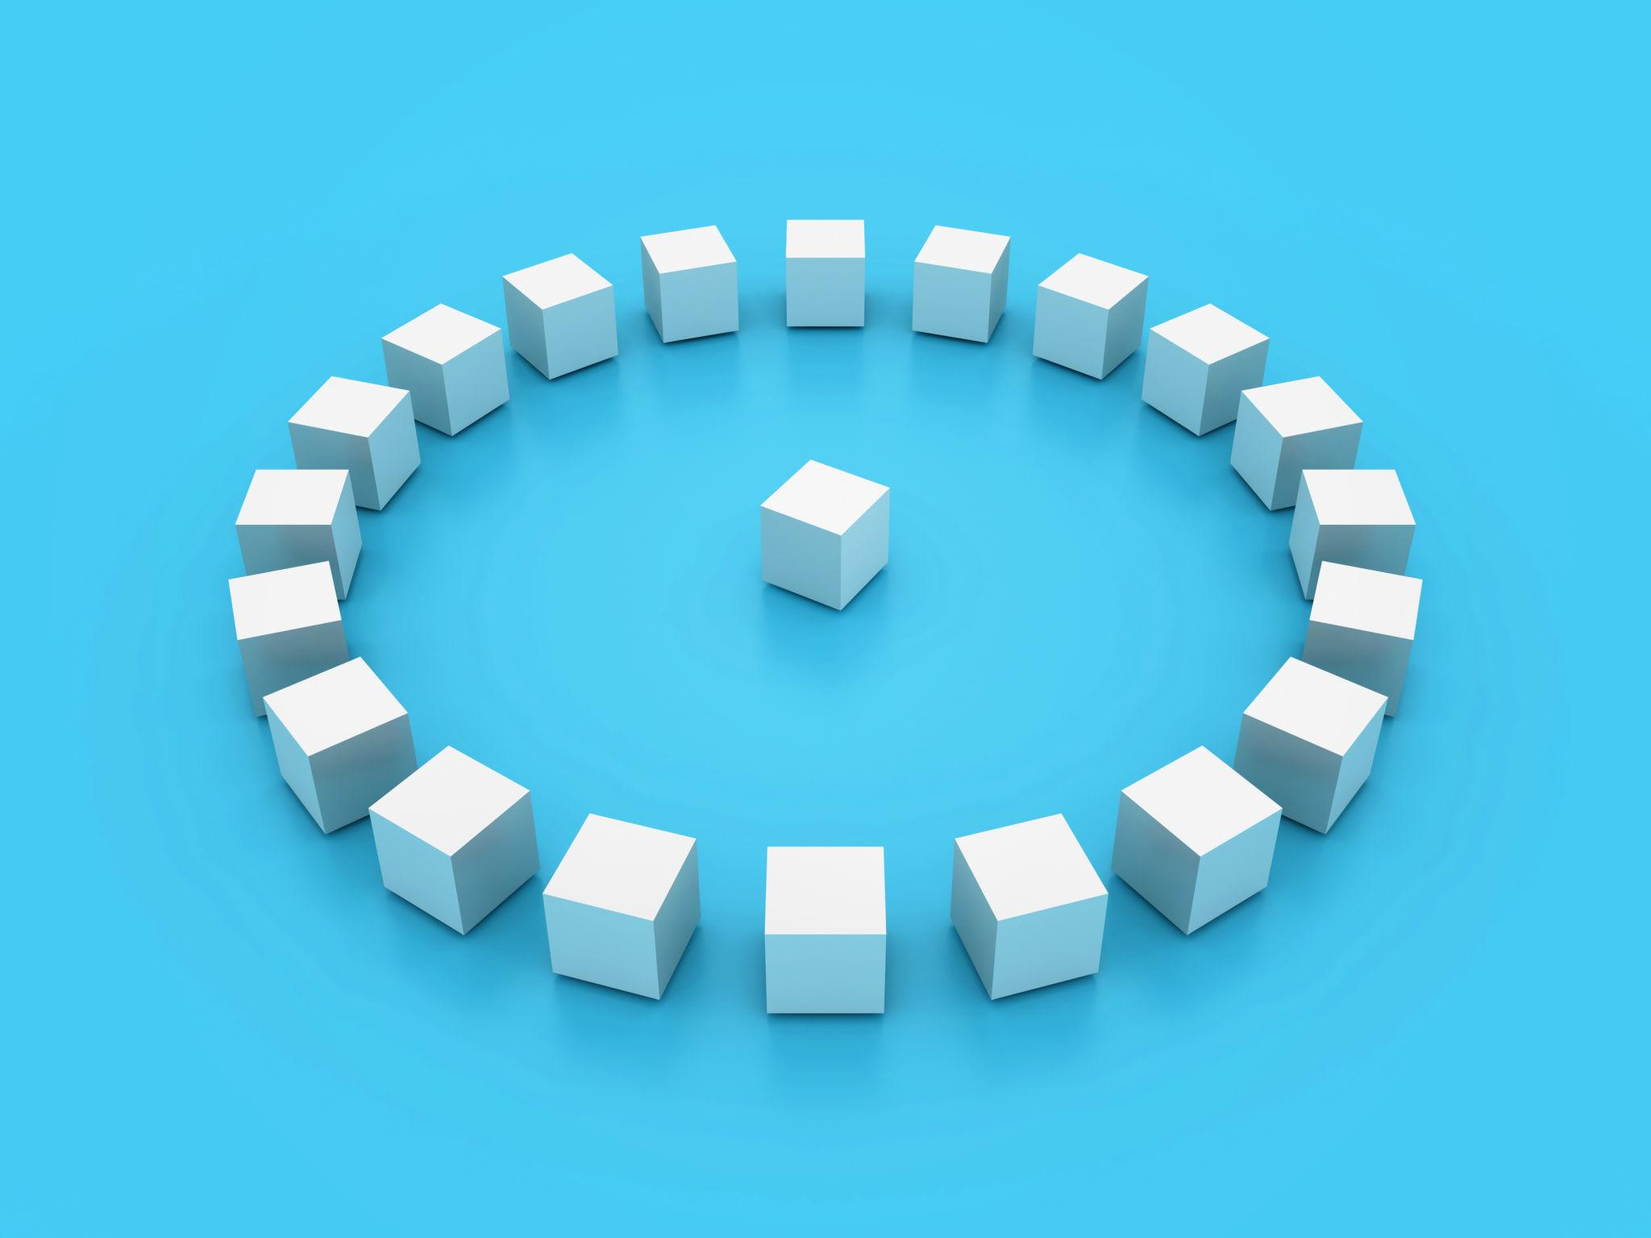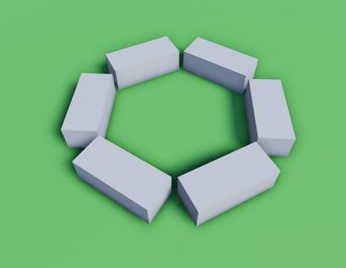

Classification by Number of Circular Rows
# Source: AI Source: Provided by: [Data Path: Persons Table -> ID Column: 1, Name_En Column: Motasem Essam] -> From: [ChatGPT] on [7/25/2026]
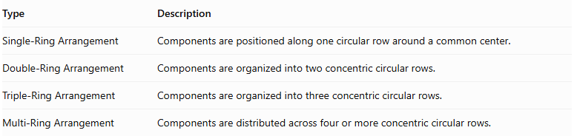
Type | Description
Single-Ring Arrangement | Components are positioned along one circular row around a common center.
Double-Ring Arrangement | Components are organized into two concentric circular rows.
Triple-Ring Arrangement | Components are organized into three concentric circular rows.
Multi-Ring Arrangement | Components are distributed across four or more concentric circular rows.
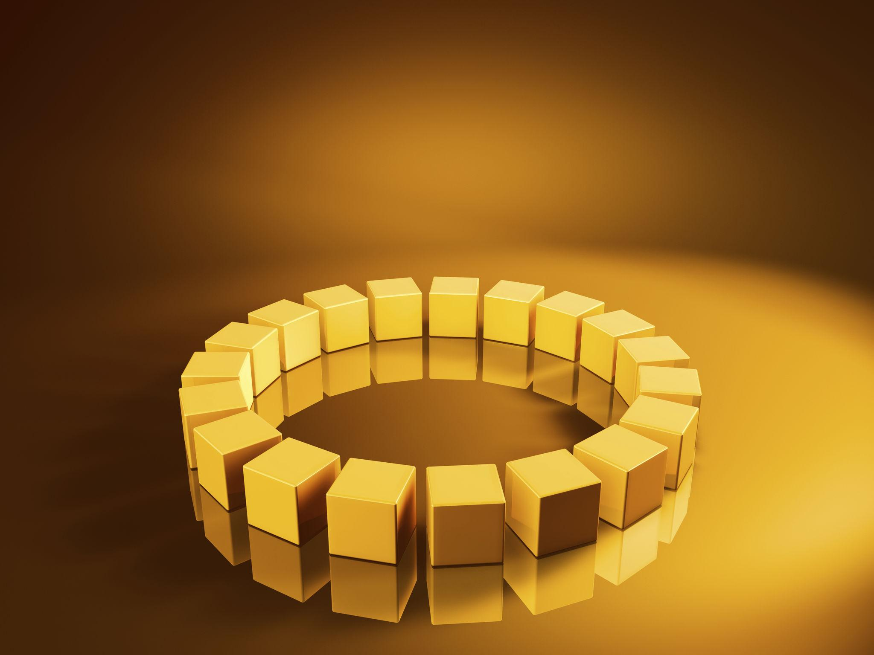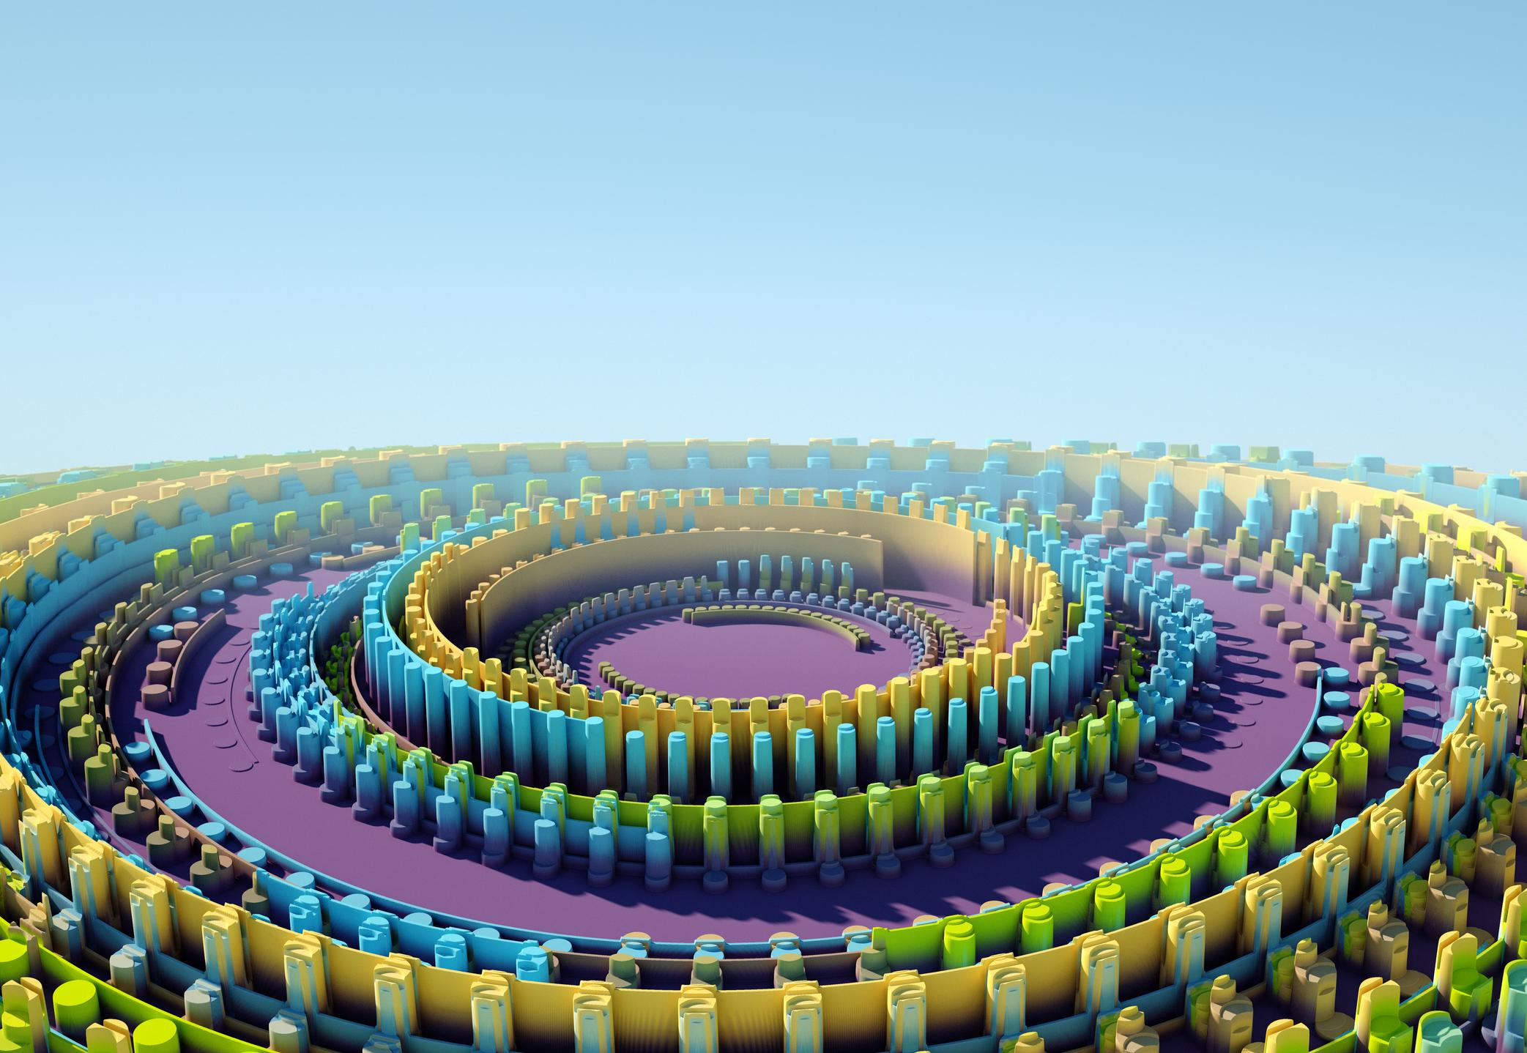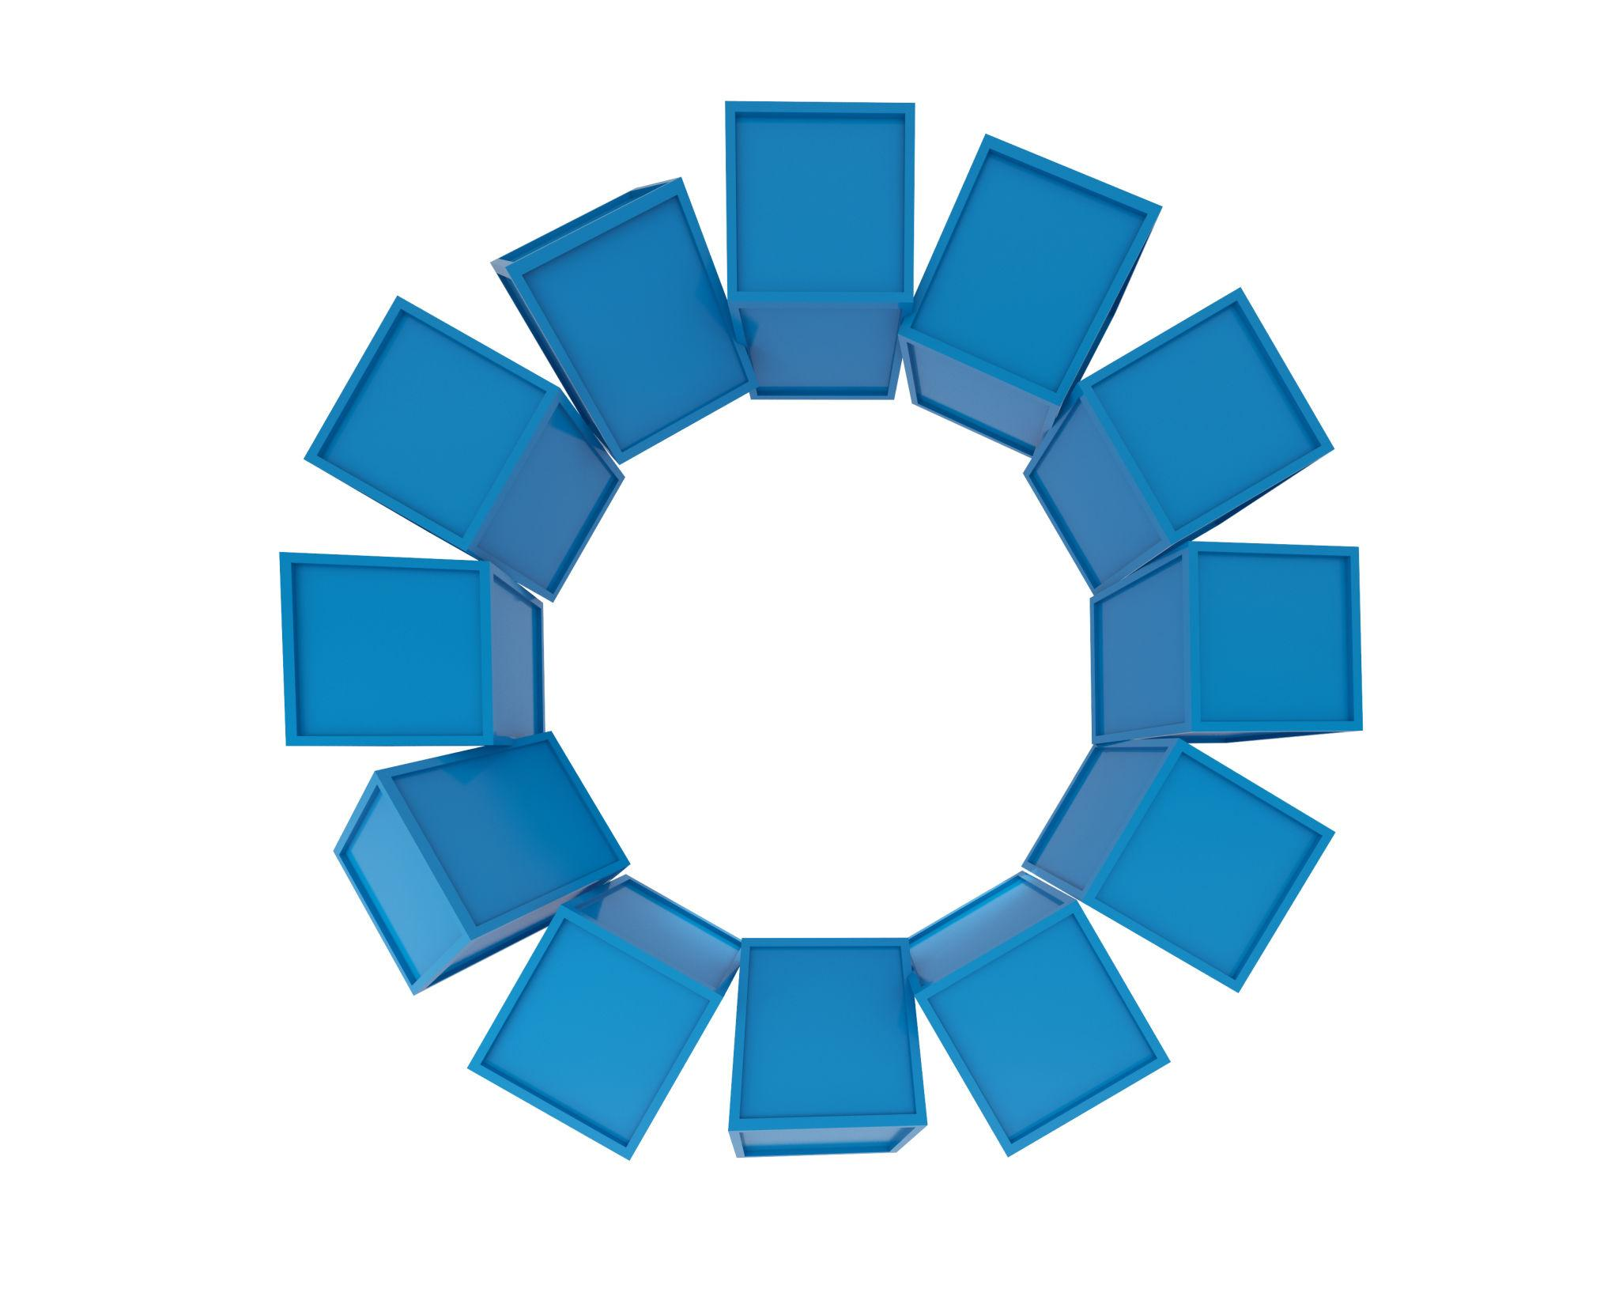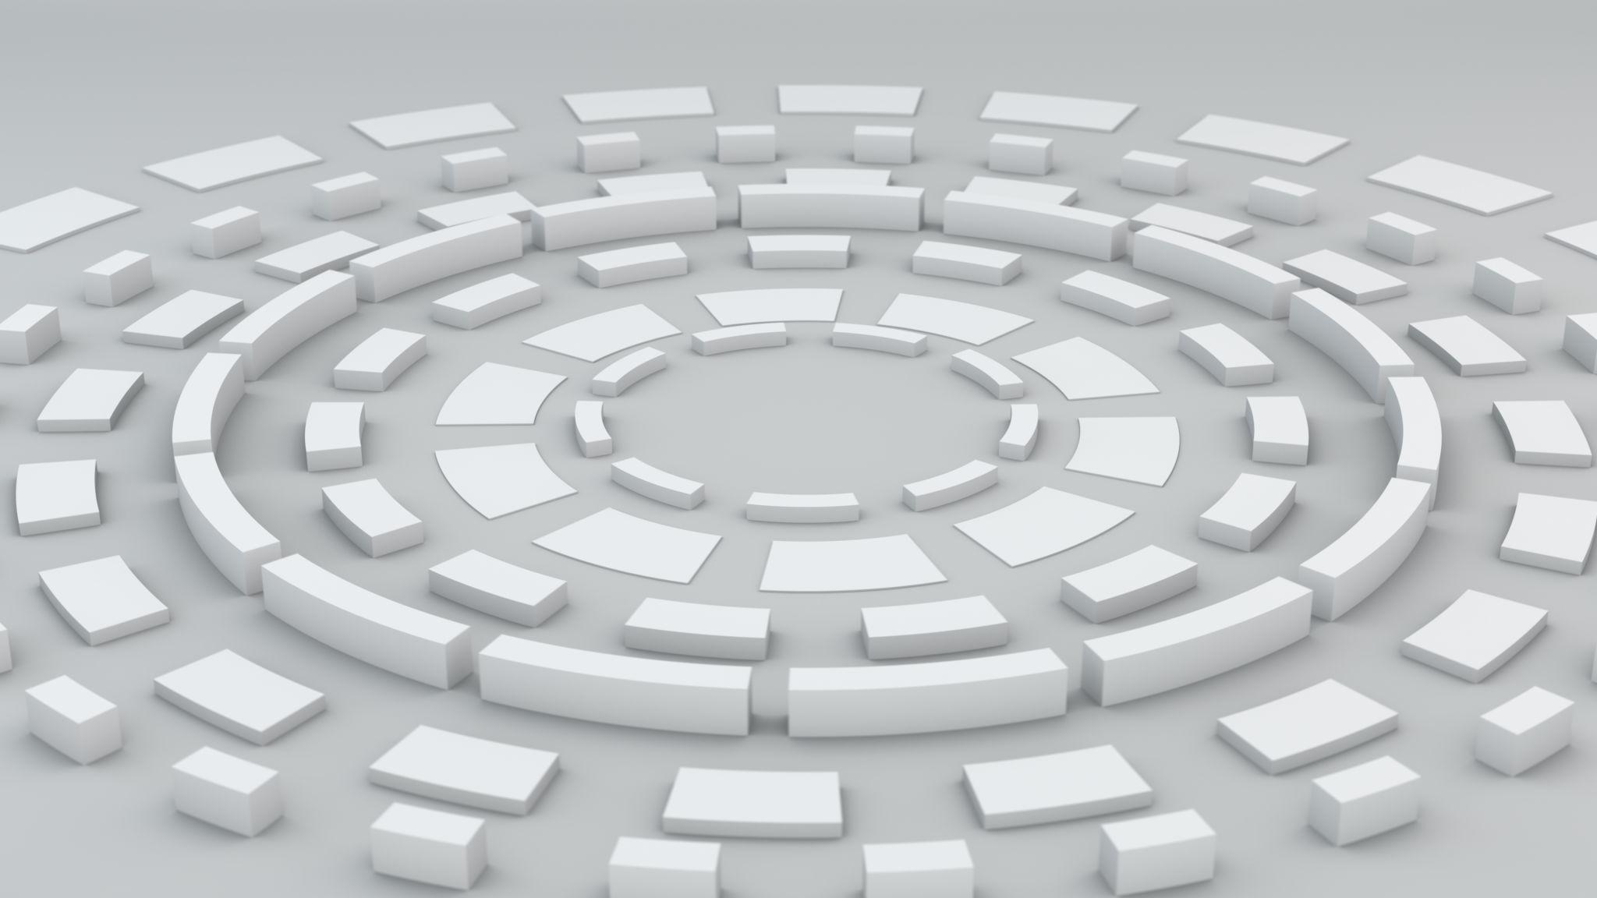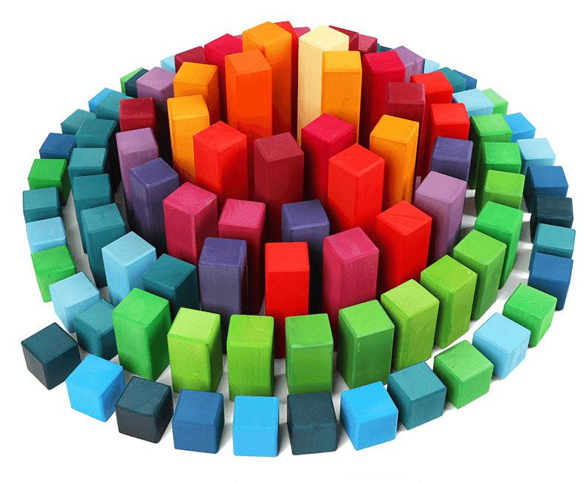

Classification by Central Configuration
# Source: AI Source: Provided by: [Data Path: Persons Table -> ID Column: 1, Name_En Column: Motasem Essam] -> From: [ChatGPT] on [7/25/2026]
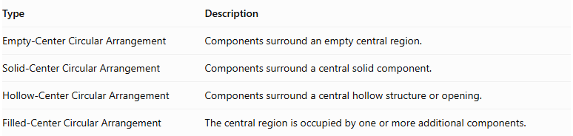
Type | Description
Empty-Center Circular Arrangement | Components surround an empty central region.
Solid-Center Circular Arrangement | Components surround a central solid component.
Hollow-Center Circular Arrangement | Components surround a central hollow structure or opening.
Filled-Center Circular Arrangement | The central region is occupied by one or more additional components.
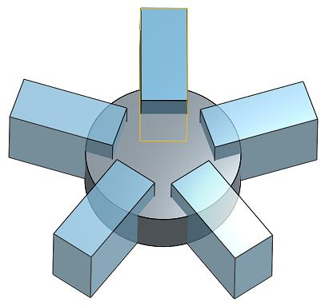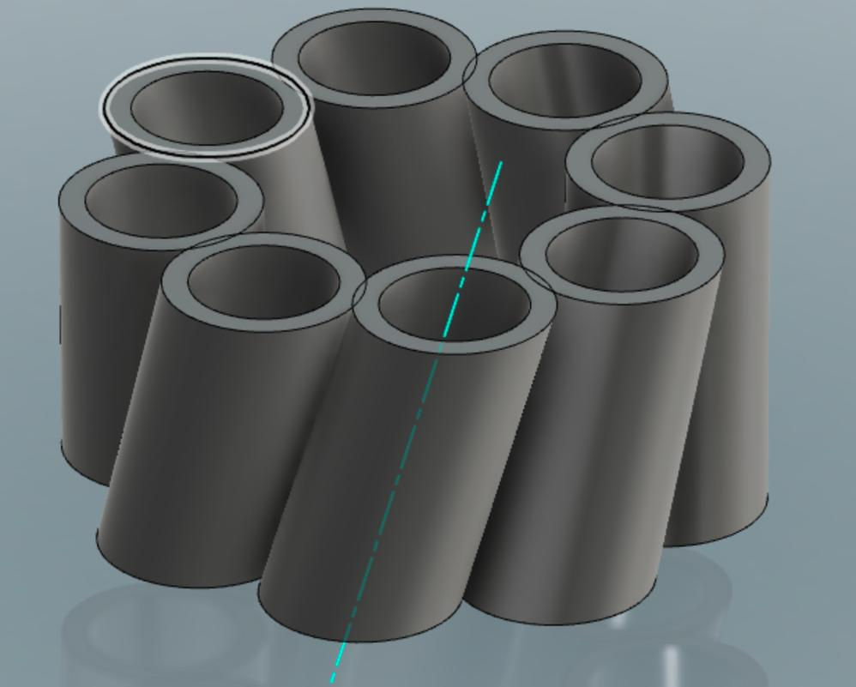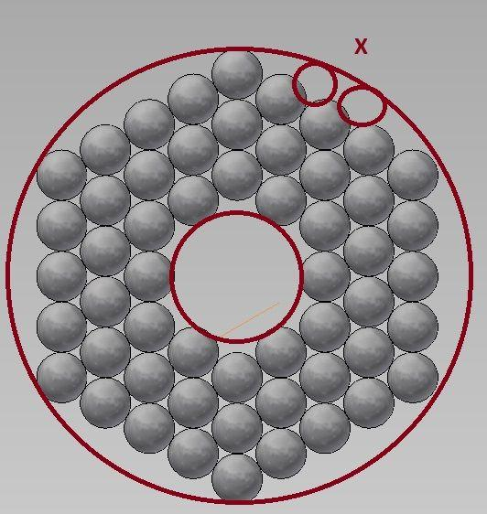

Classification by Component Distribution
# Source: AI Source: Provided by: [Data Path: Persons Table -> ID Column: 1, Name_En Column: Motasem Essam] -> From: [ChatGPT] on [7/25/2026]
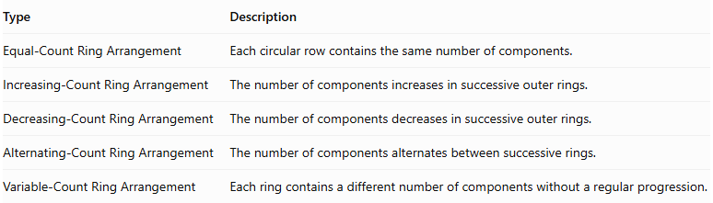
Type | Description
Equal-Count Ring Arrangement | Each circular row contains the same number of components.
Increasing-Count Ring Arrangement | The number of components increases in successive outer rings.
Decreasing-Count Ring Arrangement | The number of components decreases in successive outer rings.
Alternating-Count Ring Arrangement | The number of components alternates between successive rings.
Variable-Count Ring Arrangement | Each ring contains a different number of components without a regular progression.
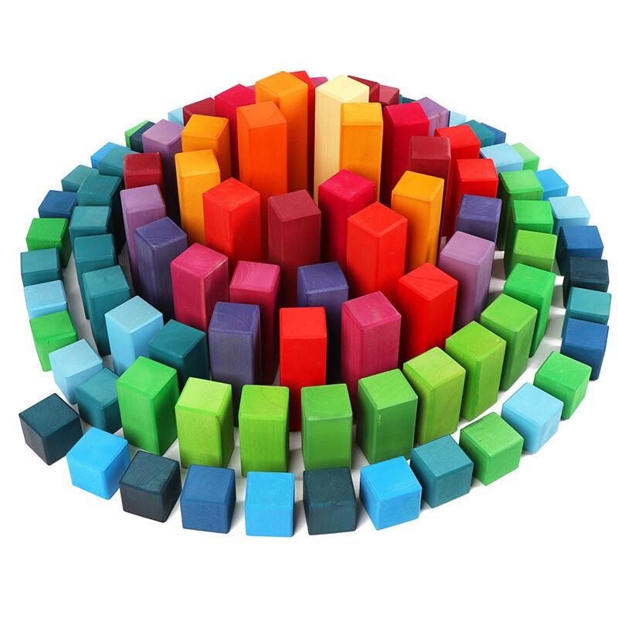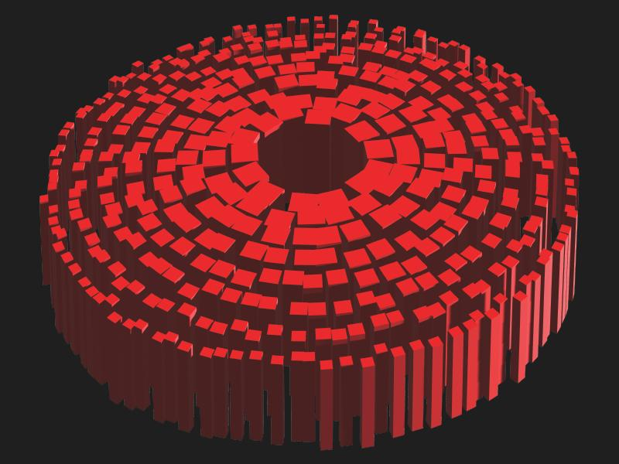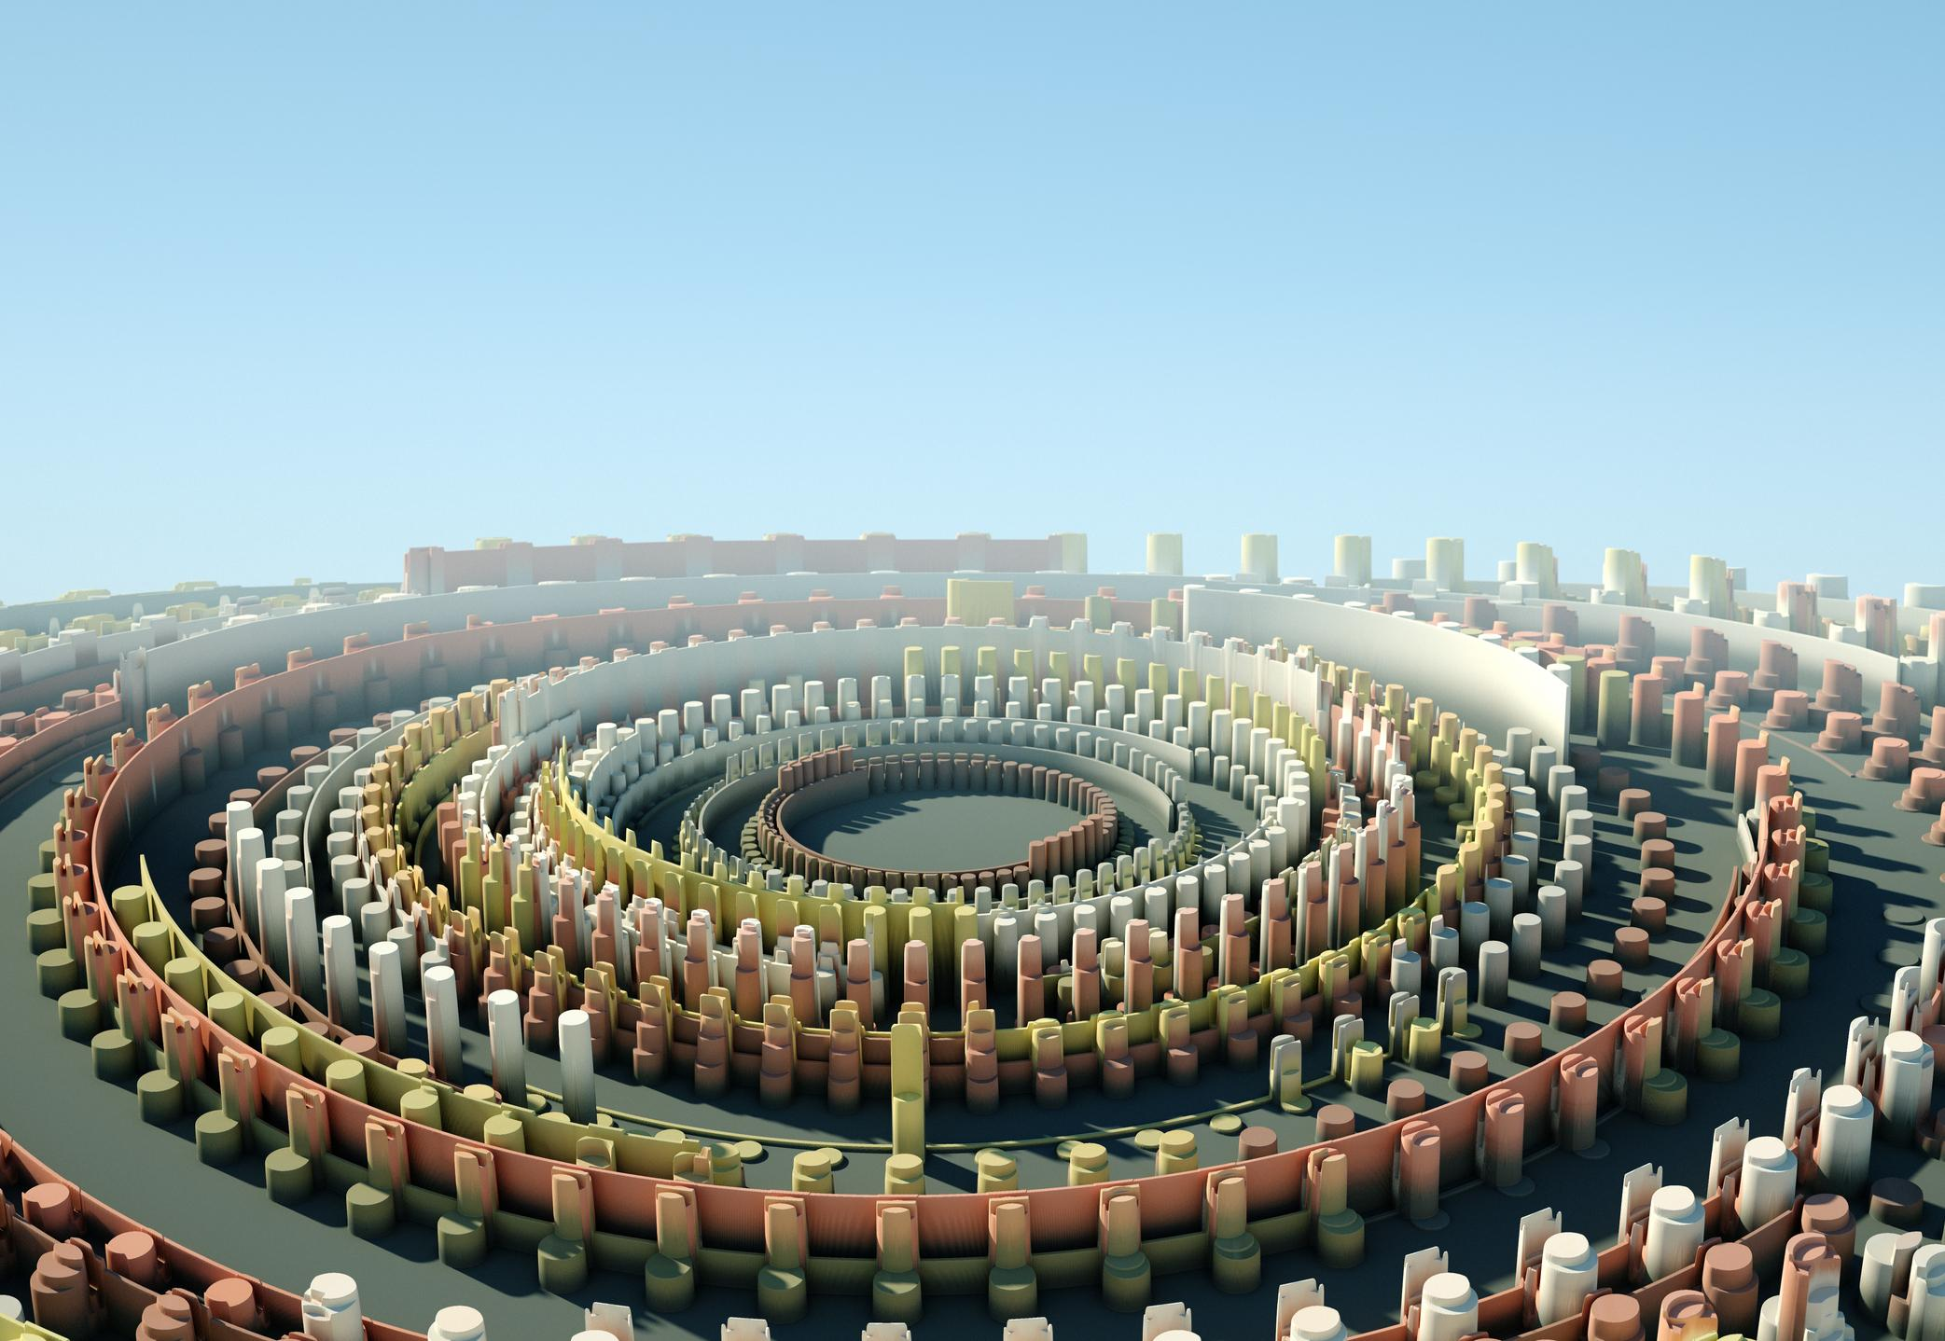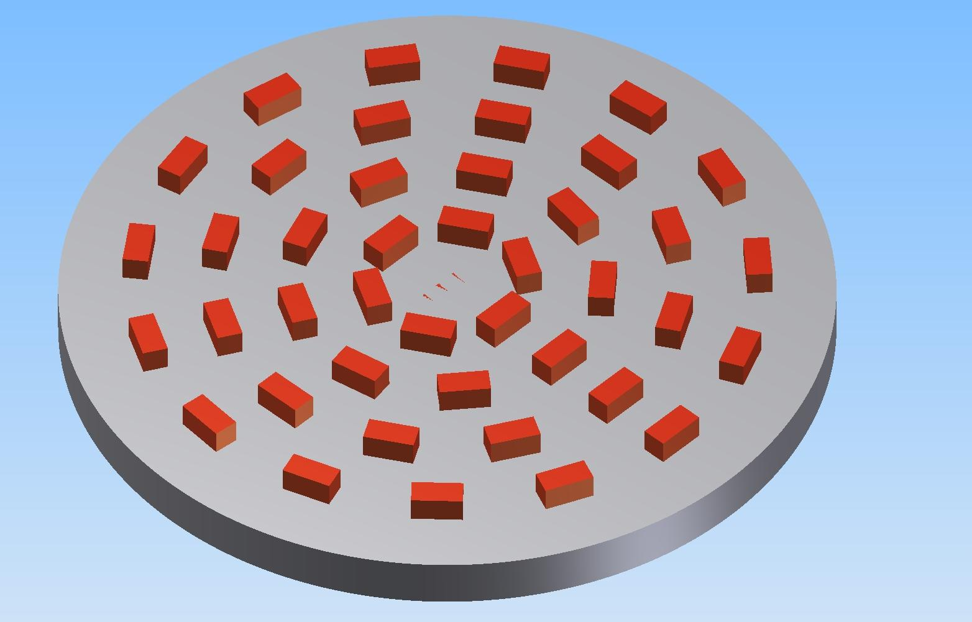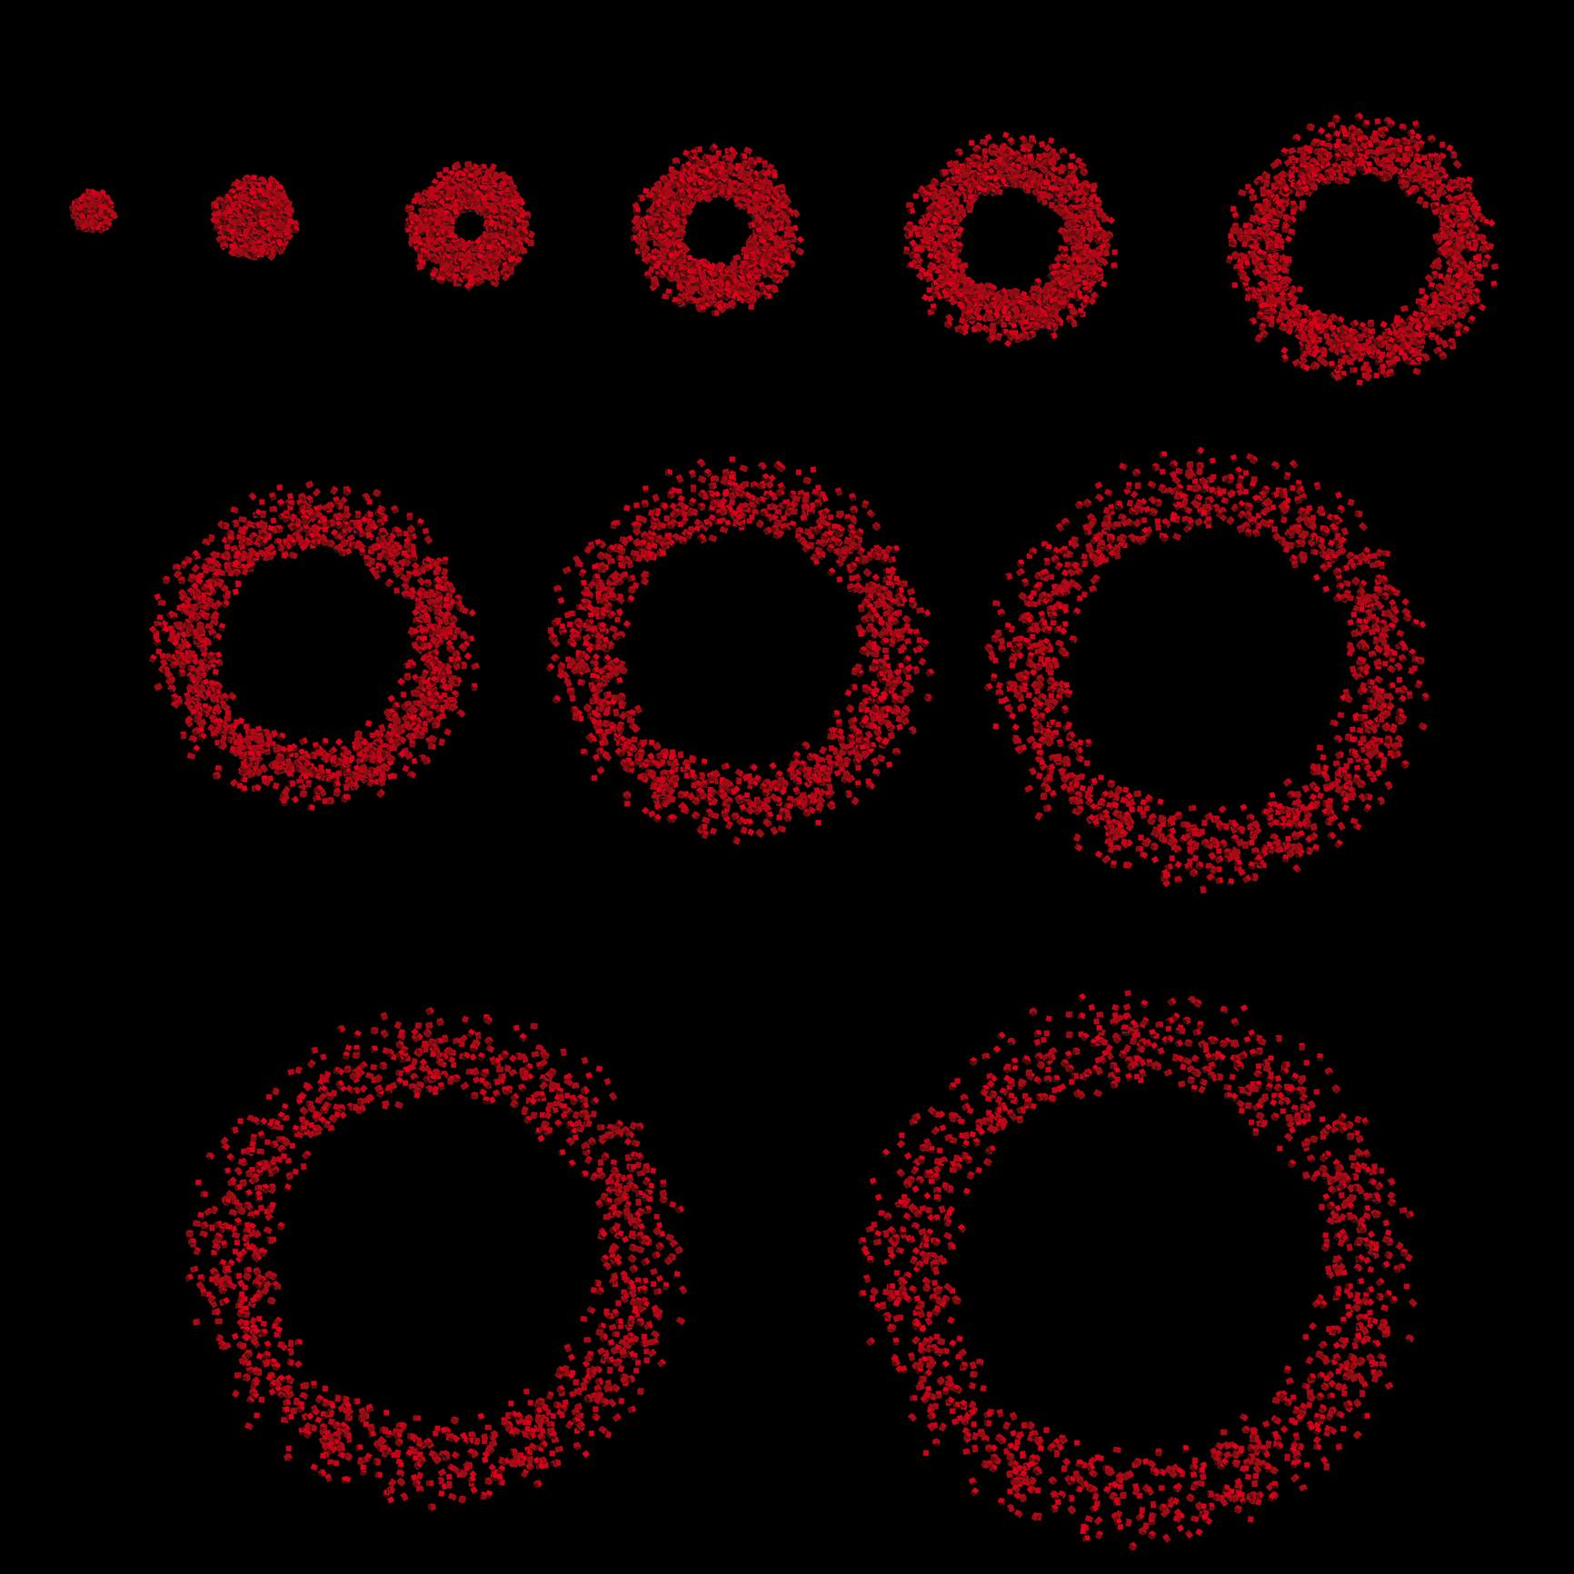

Classification by Component Orientation
# Source: AI Source: Provided by: [Data Path: Persons Table -> ID Column: 1, Name_En Column: Motasem Essam] -> From: [ChatGPT] on [7/25/2026]
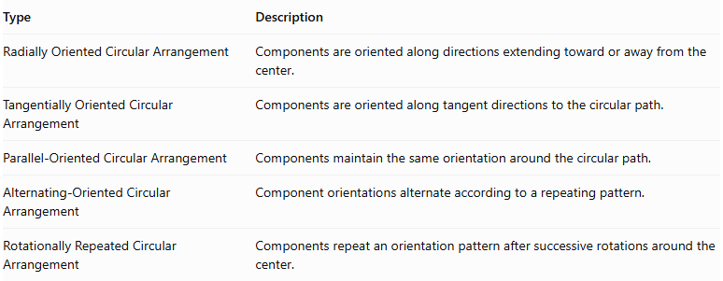
Type | Description
Radially Oriented Circular Arrangement | Components are oriented along directions extending toward or away from the center.
Tangentially Oriented Circular Arrangement | Components are oriented along tangent directions to the circular path.
Parallel-Oriented Circular Arrangement | Components maintain the same orientation around the circular path.
Alternating-Oriented Circular Arrangement | Component orientations alternate according to a repeating pattern.
Rotationally Repeated Circular Arrangement | Components repeat an orientation pattern after successive rotations around the center.
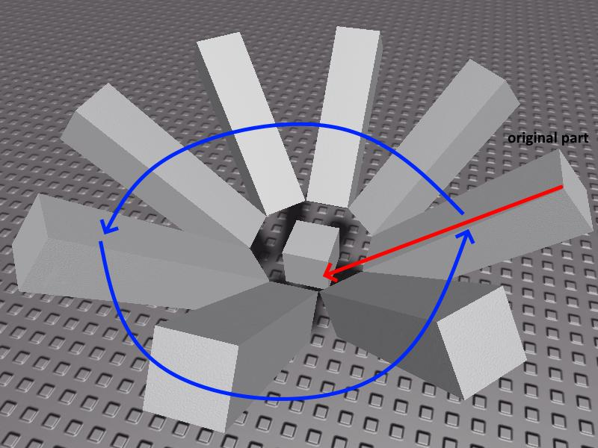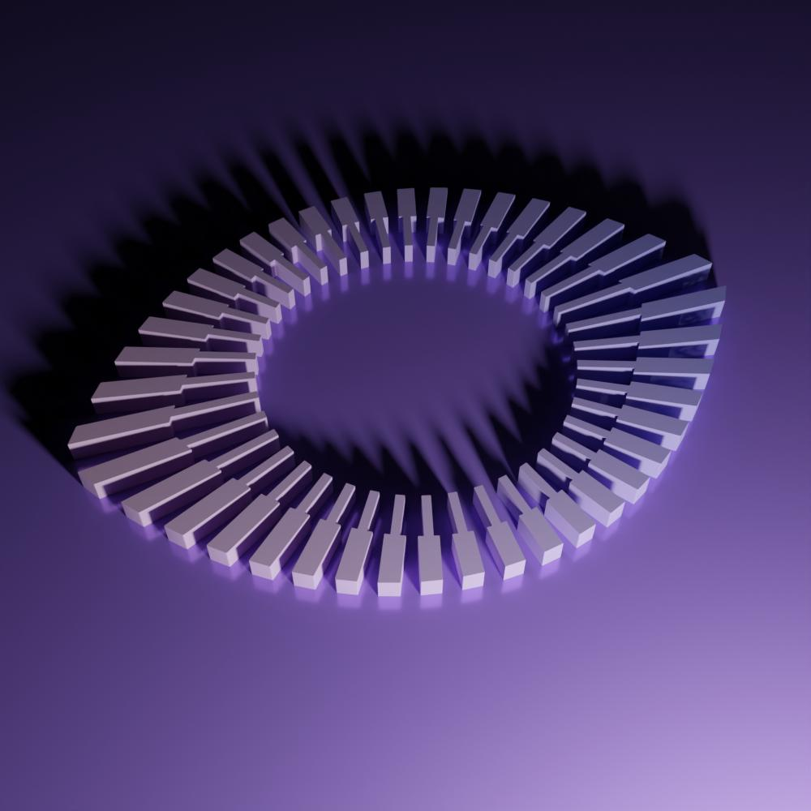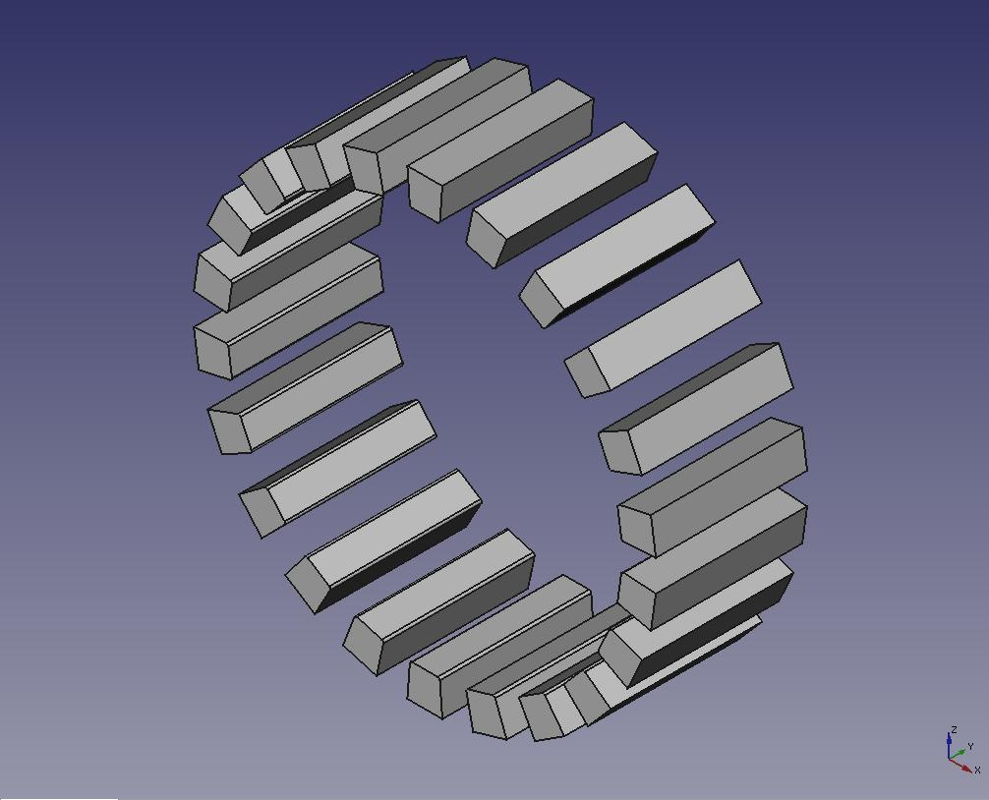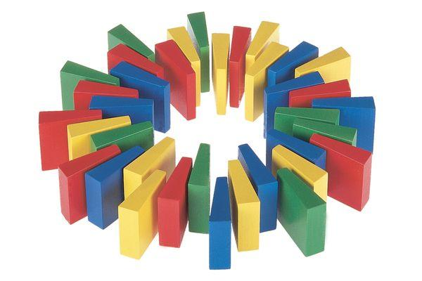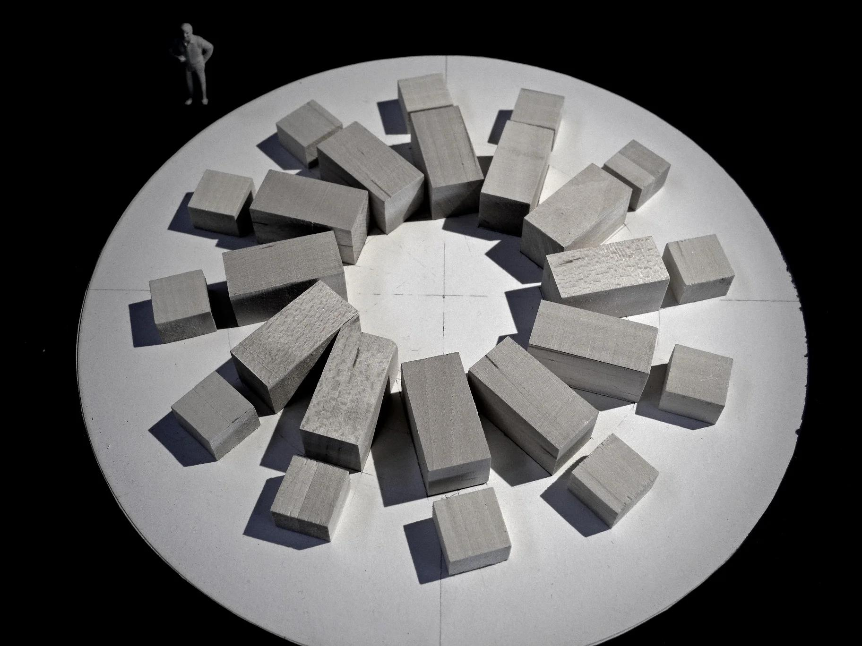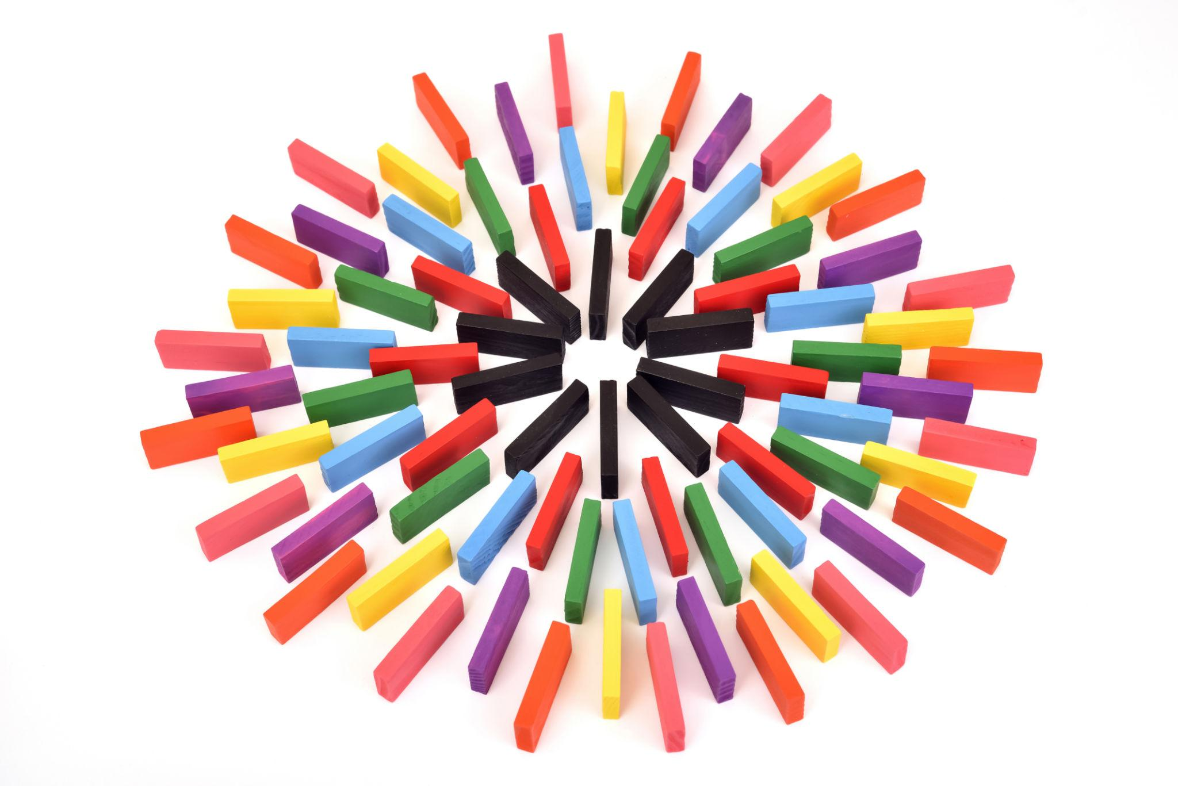

Classification by Component Shape
# Source: AI Source: Provided by: [Data Path: Persons Table -> ID Column: 1, Name_En Column: Motasem Essam] -> From: [ChatGPT] on [7/25/2026]
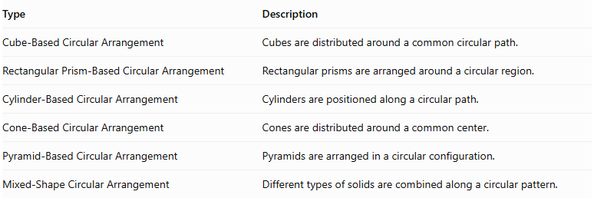
Type | Description
Cube-Based Circular Arrangement | Cubes are distributed around a common circular path.
Rectangular Prism-Based Circular Arrangement | Rectangular prisms are arranged around a circular region.
Cylinder-Based Circular Arrangement | Cylinders are positioned along a circular path.
Cone-Based Circular Arrangement | Cones are distributed around a common center.
Pyramid-Based Circular Arrangement | Pyramids are arranged in a circular configuration.
Mixed-Shape Circular Arrangement | Different types of solids are combined along a circular pattern.
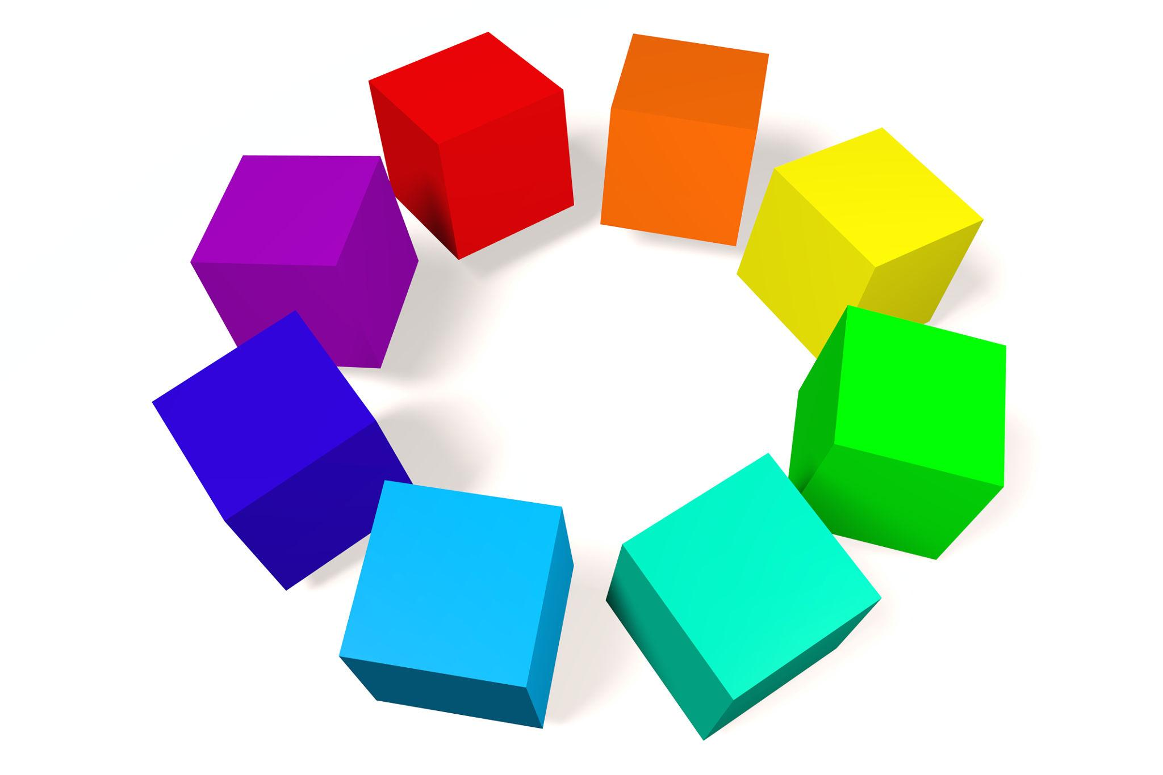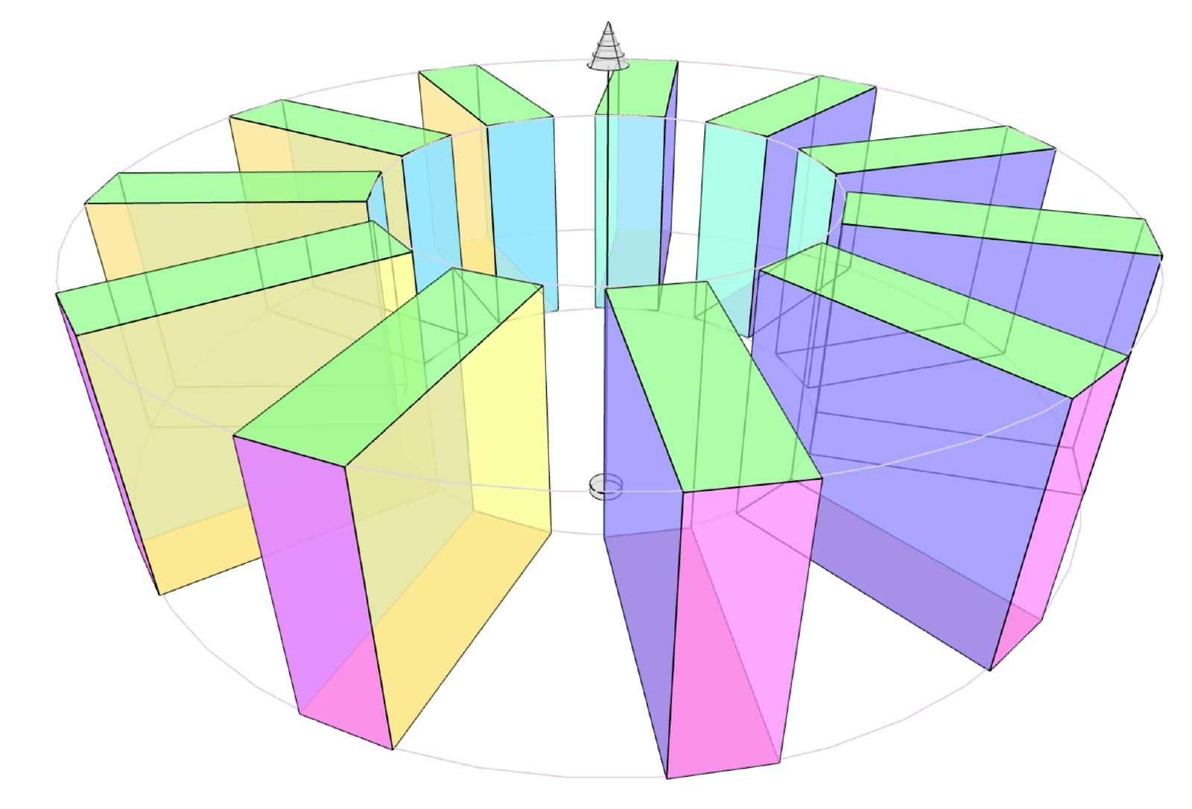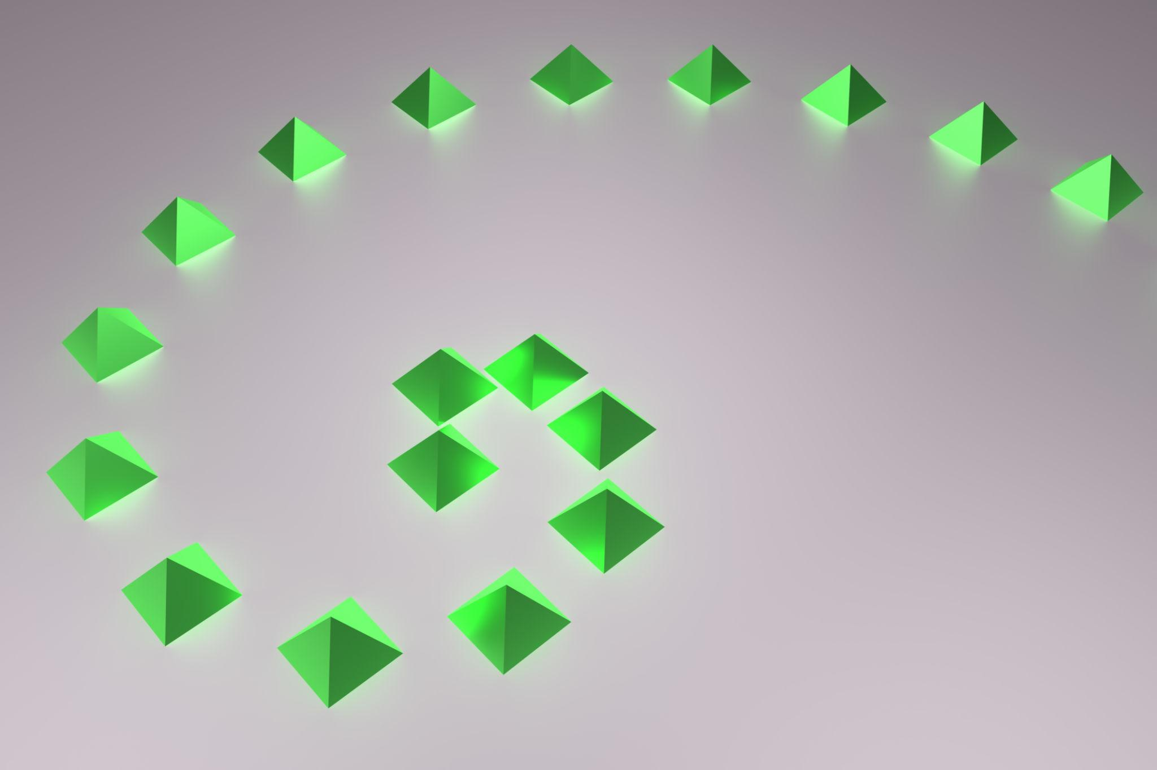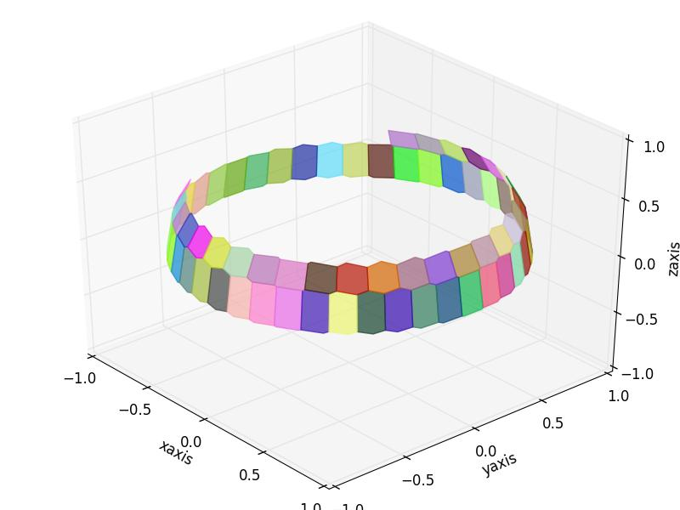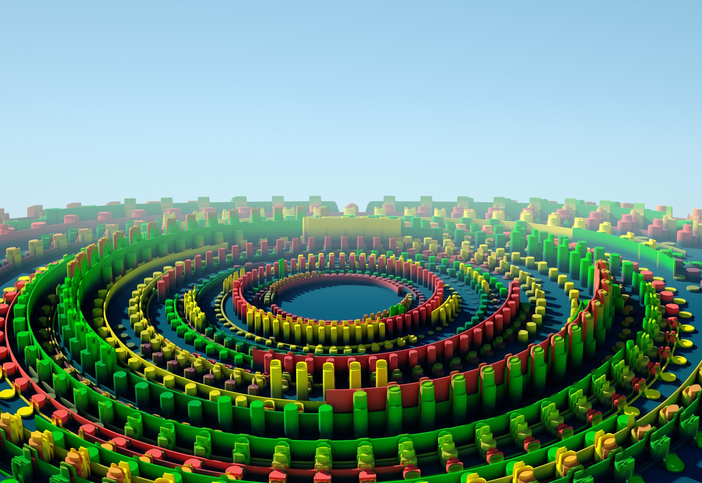

Mathematical Properties and Formulas

Angular Separation
# Source: AI Source: Provided by: [Data Path: Persons Table -> ID Column: 1, Name_En Column: Motasem Essam] -> From: [ChatGPT] on [7/25/2026]
For $N$ equally spaced components arranged around a complete circle:
$$\boxed{θ=\frac{{360}^{∘}}{N}}$$
Where:
- $θ$ = Angular separation between consecutive components.
- $N$ = Number of components.
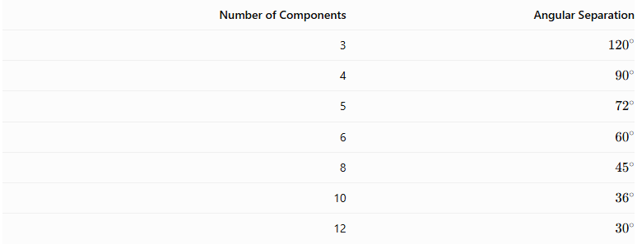
Number of Components | Angular Separation
3 | $${120}^{∘}$$
4 | $${90}^{∘}$$
5 | $${72}^{∘}$$
6 | $${60}^{∘}$$
8 | $${45}^{∘}$$
10 | $${36}^{∘}$$
12 | $${30}^{∘}$$

Circumference of the Circular Path
# Source: AI Source: Provided by: [Data Path: Persons Table -> ID Column: 1, Name_En Column: Motasem Essam] -> From: [ChatGPT] on [7/25/2026]
$$\boxed{C=2πR}$$
Where:
- $C$ = Circumference.
- $R$ = Radius of the circular path.

Distance Between Consecutive Component Centers
# Source: AI Source: Provided by: [Data Path: Persons Table -> ID Column: 1, Name_En Column: Motasem Essam] -> From: [ChatGPT] on [7/25/2026]
For equally spaced components on a circular path, the straight-line distance between neighboring centers is called the chord length.
$$\boxed{d=2Rsin(\frac{π}{N})}$$
Where:
- $d$ = Distance between consecutive component centers.
- $R$ = Radius of the circular path.
- $N$ = Number of equally spaced components.

Component Position
# Source: AI Source: Provided by: [Data Path: Persons Table -> ID Column: 1, Name_En Column: Motasem Essam] -> From: [ChatGPT] on [7/25/2026]
The center of each component can be located using polar coordinates:
$$x_{i}=Rcosθ_{i}$$
$$y_{i}=Rsinθ_{i}$$
For equally spaced components:
$$\boxed{θ_{i}=θ_{0}+\frac{{360}^{∘}i}{N}}$$
Where:
- $θ_{0}$ = Initial angular position.
- $i$ = Component index, starting at zero.
These formulas locate component reference points, not the complete boundaries of the solids.

Total Number of Components
# Source: AI Source: Provided by: [Data Path: Persons Table -> ID Column: 1, Name_En Column: Motasem Essam] -> From: [ChatGPT] on [7/25/2026]
For multiple circular rings:
$$\boxed{N_{total}=N_{c}+\sum_{i=1}^{R}{N_{i}}}$$
Where:
- $N_{c}$ = Number of central components.
- $R$ = Number of circular rings.
- $N_{i}$ = Number of components in ring $i$.

Total Volume
# Source: AI Source: Provided by: [Data Path: Persons Table -> ID Column: 1, Name_En Column: Motasem Essam] -> From: [ChatGPT] on [7/25/2026]
For non-overlapping components:
$$\boxed{V_{total}=\sum_{i=1}^{N}{V_{i}}}$$
For identical components:
$$\boxed{V_{total}=N×V_{component}}$$

External Surface Area
# Source: AI Source: Provided by: [Data Path: Persons Table -> ID Column: 1, Name_En Column: Motasem Essam] -> From: [ChatGPT] on [7/25/2026]
The external surface area includes only the exposed surfaces of all components after assembly.
For complete matching planar interfaces:
$${SA}_{external}=\sum{{SA}_{i}}-2\sum{A_{interface}}$$
For curved contact or partial intersections, the actual hidden surface regions must be calculated separately.

Worked Examples

Example 1: Six Cubes Arranged in a Circular Pattern
# Source: AI Source: Provided by: [Data Path: Persons Table -> ID Column: 1, Name_En Column: Motasem Essam] -> From: [ChatGPT] on [7/25/2026]
Problem:
Six identical cubes are arranged around a circular path, with their centers equally spaced. Each cube has a side length of 3 cm.
The cubes do not overlap or touch.
Calculate:
- The angular separation.
- The total volume of the six cubes.
- The total number of cubes.
- The distance between consecutive cube centers if the circular path has a radius of 6 cm.
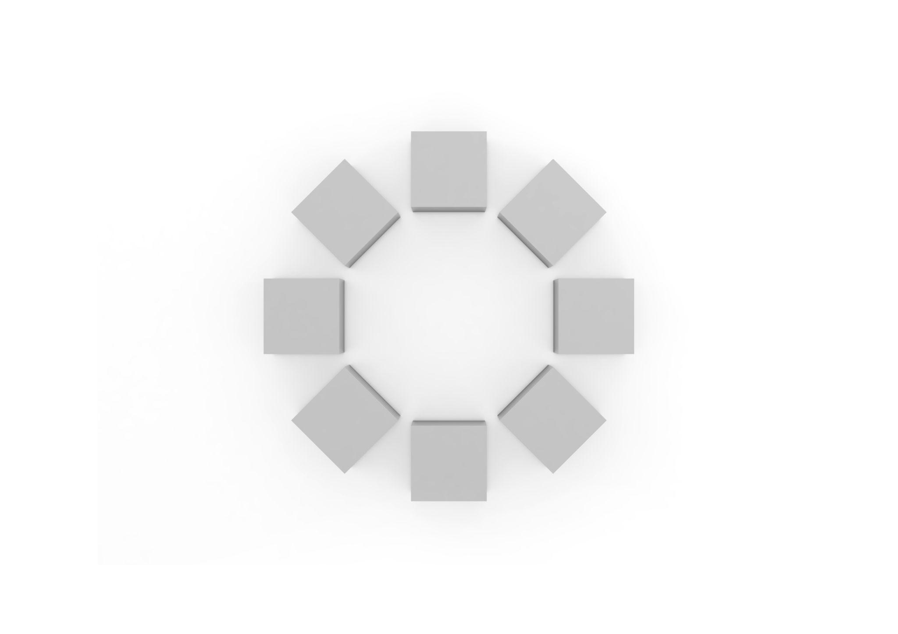
Step 1: Calculate the angular separation.
$$θ=\frac{{360}^{∘}}{6}$$
$$\boxed{θ={60}^{∘}}$$
Step 2: Calculate the volume of one cube.
$$V=s^{3}$$
$$V=3^{3}=27{ cm}^{3}$$
Step 3: Calculate the total volume.
$$V_{total}=6×27$$
$$\boxed{V_{total}=162{ cm}^{3}}$$
Step 4: Calculate the total number of cubes.
$$\boxed{N_{total}=6}$$
Step 5: Calculate the distance between consecutive cube centers.
$$d=2Rsin(\frac{π}{N})$$
Substitute:
$$d=2(6)sin(\frac{{180}^{∘}}{6})$$
$$d=12sin{30}^{∘}$$
$$\boxed{d=6 cm}$$

Example 2: Two Concentric Circular Rings of Cylinders
# Source: AI Source: Provided by: [Data Path: Persons Table -> ID Column: 1, Name_En Column: Motasem Essam] -> From: [ChatGPT] on [7/25/2026]
Problem:
A composite arrangement consists of two concentric circular rings of identical cylinders.
- Inner ring: 6 cylinders.
- Outer ring: 12 cylinders.
- Radius of each cylinder: 2 cm.
- Height of each cylinder: 5 cm.
Calculate:
- The total number of cylinders.
- The total volume.
- The angular separation in each ring.
Assume the cylinders are separate, non-overlapping components.
Step 1: Calculate the total number of cylinders.
$$N_{total}=6+12$$
$$\boxed{N_{total}=18}$$
Step 2: Calculate the volume of one cylinder.
$$V=πr^{2}h$$
$$V=π(2)^{2}(5)$$
$$V=20π{ cm}^{3}$$
Step 3: Calculate the total volume.
$$V_{total}=18×20π$$
$$\boxed{V_{total}=360π≈1130.97{ cm}^{3}}$$
Step 4: Calculate the angular separation of the inner ring.
$$θ_{1}=\frac{{360}^{∘}}{6}$$
$$\boxed{θ_{1}={60}^{∘}}$$
Step 5: Calculate the angular separation of the outer ring.
$$θ_{2}=\frac{{360}^{∘}}{12}$$
$$\boxed{θ_{2}={30}^{∘}}$$

Important Characteristics
# Source: AI Source: Provided by: [Data Path: Persons Table -> ID Column: 1, Name_En Column: Motasem Essam] -> From: [ChatGPT] on [7/25/2026]
- Components are distributed around a common center.
- Their reference points follow a circular path or concentric circular paths.
- Components may be equally spaced or unevenly distributed.
- The arrangement may have an empty center or a central solid.
- Multiple concentric rings can be used.
- Different rings may contain different numbers of components.
- Components may be oriented radially, tangentially, or parallel to one another.
- The arrangement may be symmetrical or asymmetrical.
- The total volume is the sum of component volumes when no overlap occurs.
- External surface area depends on the actual contact and intersection regions.

Comparison with Other Component Arrangements
# Source: AI Source: Provided by: [Data Path: Persons Table -> ID Column: 1, Name_En Column: Motasem Essam] -> From: [ChatGPT] on [7/25/2026]
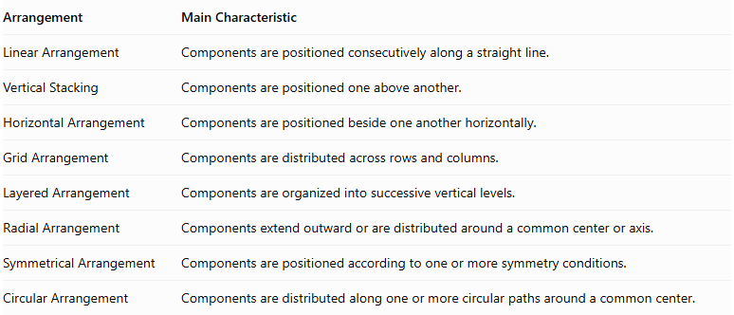
Arrangement | Main Characteristic
Linear Arrangement | Components are positioned consecutively along a straight line.
Vertical Stacking | Components are positioned one above another.
Horizontal Arrangement | Components are positioned beside one another horizontally.
Grid Arrangement | Components are distributed across rows and columns.
Layered Arrangement | Components are organized into successive vertical levels.
Radial Arrangement | Components extend outward or are distributed around a common center or axis.
Symmetrical Arrangement | Components are positioned according to one or more symmetry conditions.
Circular Arrangement | Components are distributed along one or more circular paths around a common center.
Circular vs. Radial Arrangement: A radial arrangement is a broader classification based on distribution around a center or axis. A circular arrangement specifically describes components positioned along circular paths. A circular arrangement may be radial, but not every radial arrangement follows a circular path.
Circular vs. Symmetrical Arrangement: A circular arrangement describes the geometric path followed by components. A symmetrical arrangement describes the matching relationships between components. A circular arrangement may be symmetrical or asymmetrical.

Real-World Applications
# Source: AI Source: Provided by: [Data Path: Persons Table -> ID Column: 1, Name_En Column: Motasem Essam] -> From: [ChatGPT] on [7/25/2026]
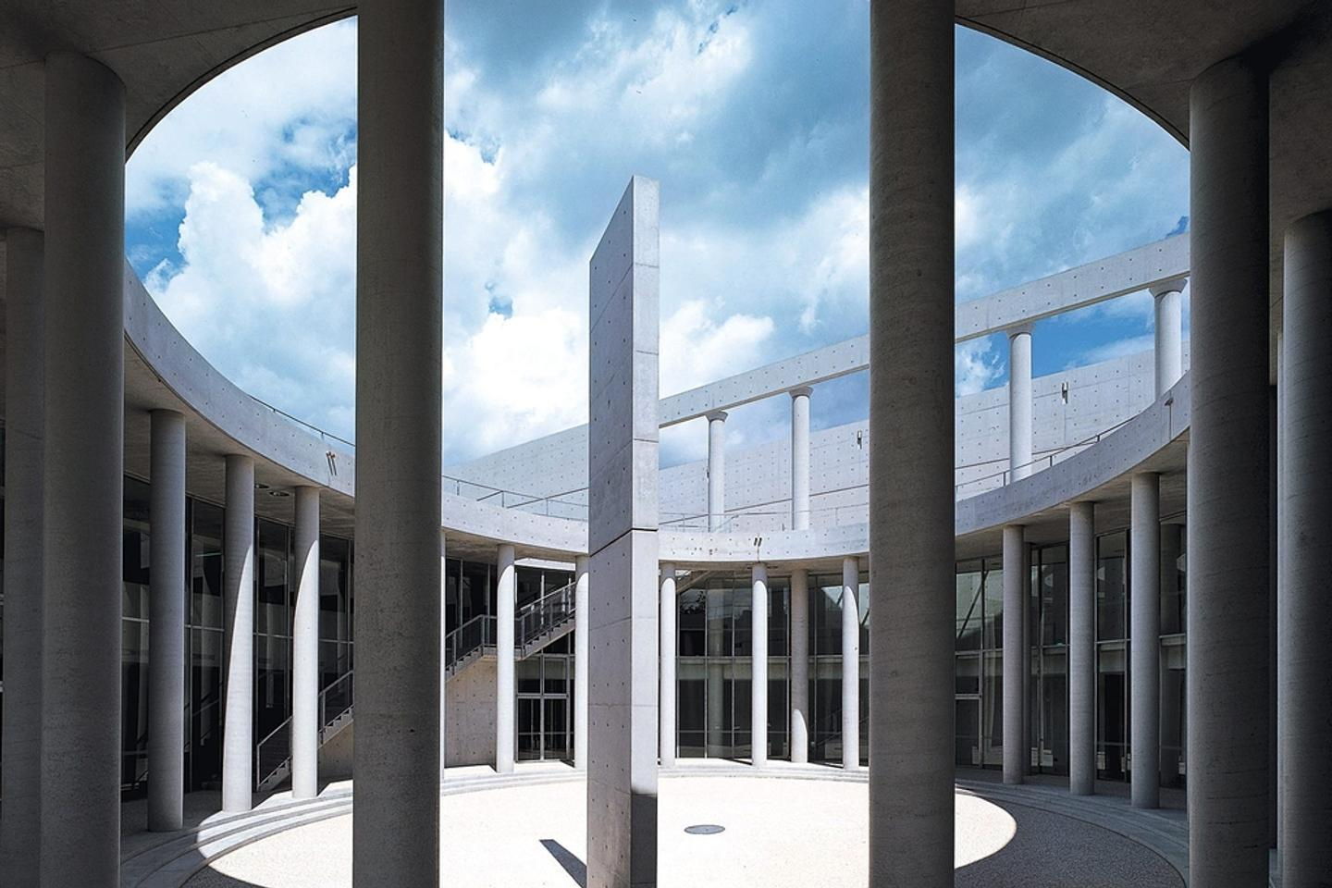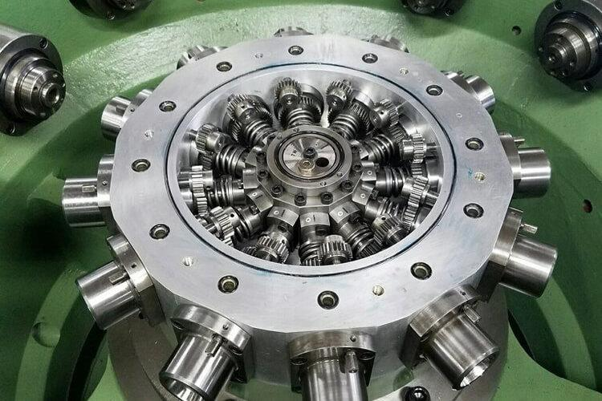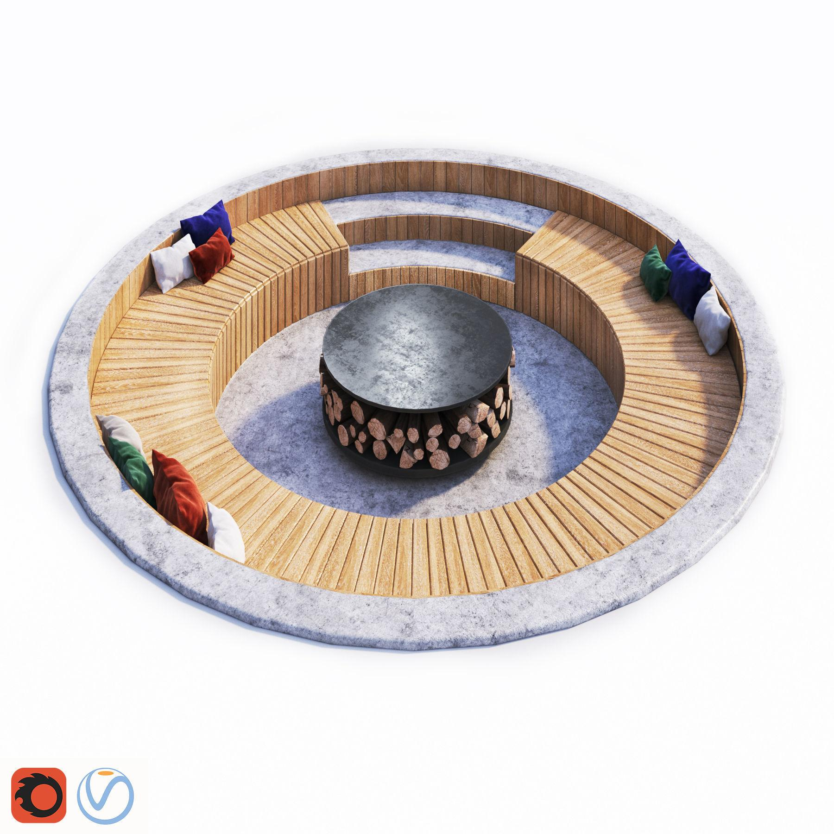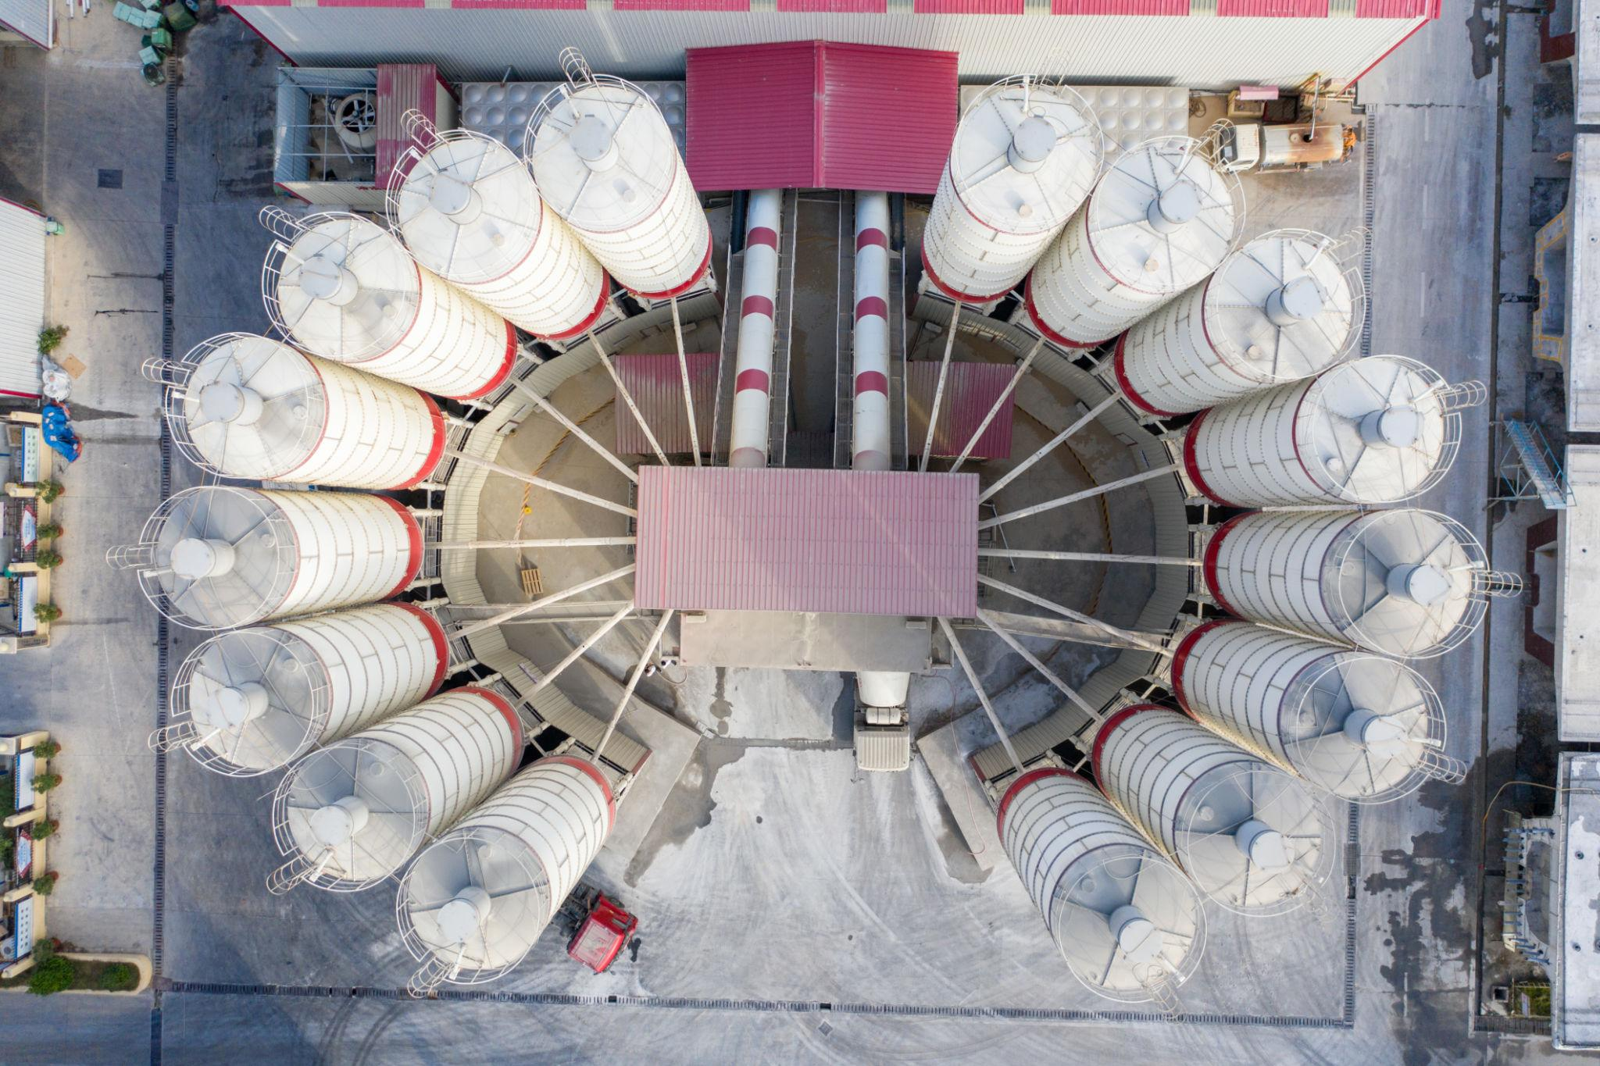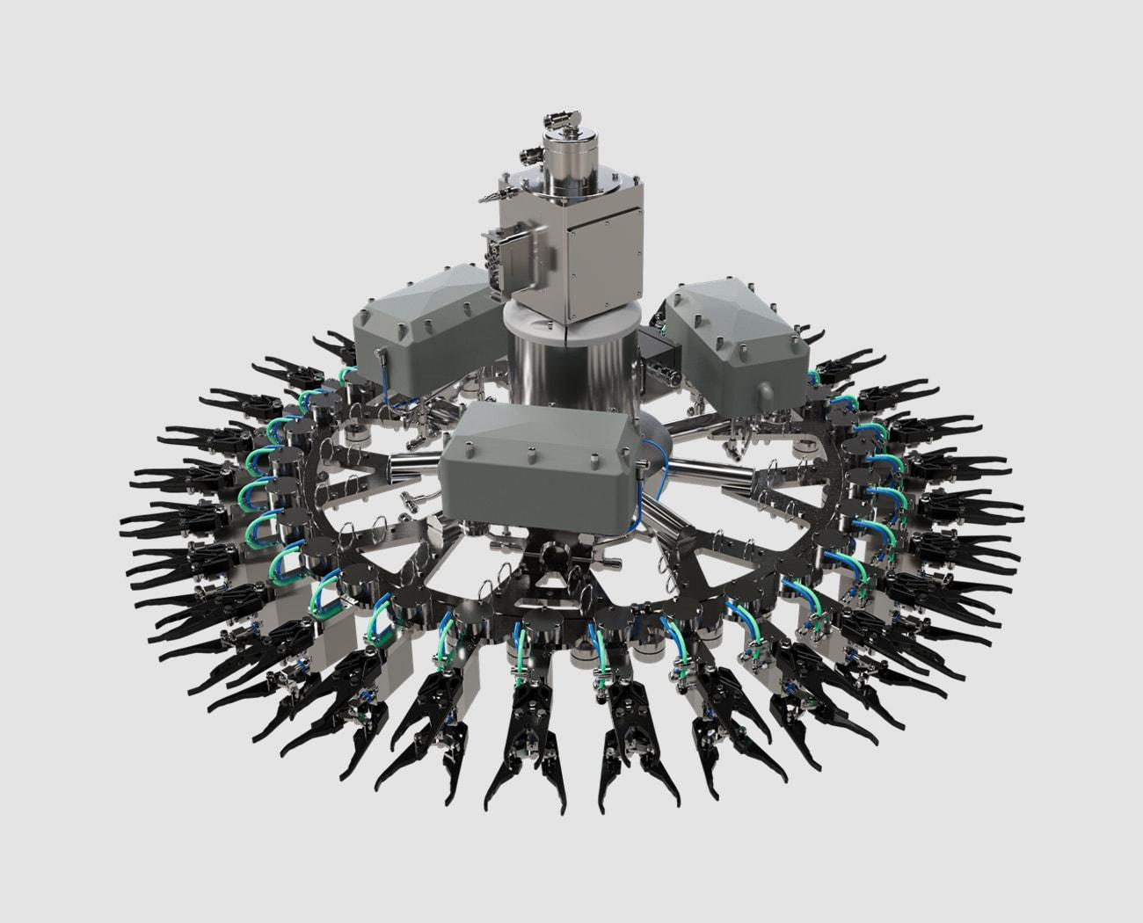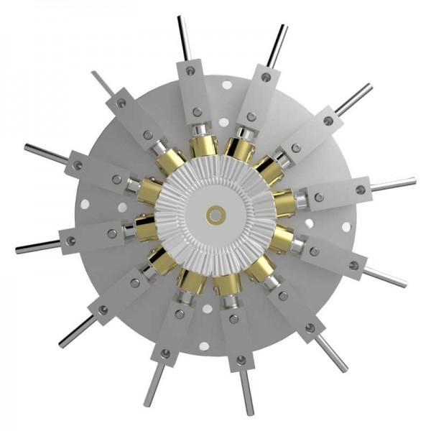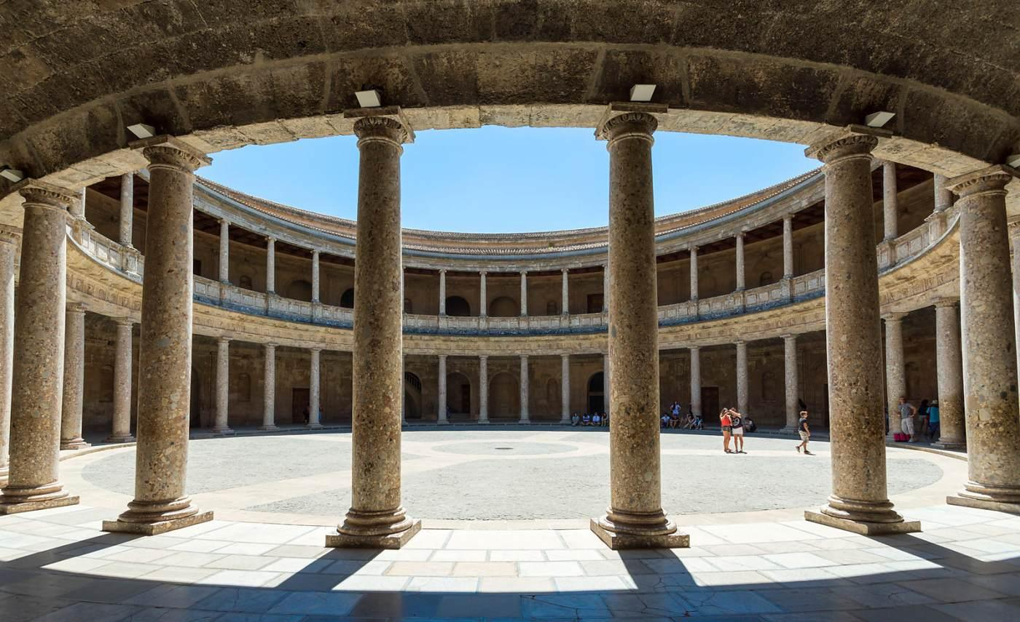
- Architecture: Circular buildings, courtyards, and structures surrounding central spaces.
- Industrial Design: Cylindrical components positioned around a central machine.
- Mechanical Engineering: Circular assemblies and rotating mechanisms.
- Construction: Circular columns and structural supports.
- Storage Systems: Containers and tanks arranged in circular patterns.
- Mathematics: Studying circumference, angular separation, chord lengths, and spatial distribution.

Key Points
# Source: AI Source: Provided by: [Data Path: Persons Table -> ID Column: 1, Name_En Column: Motasem Essam] -> From: [ChatGPT] on [7/25/2026]
- A circular arrangement positions components along circular paths.
- Components may be equally or unequally spaced.
- One or multiple concentric rings may be used.
- The center may be empty, hollow, or occupied by a solid.
- Equal angular spacing is calculated using ${360}^{∘}/N$.
- The distance between neighboring component centers can be calculated using the chord formula.
- Circular arrangements may also be radial and symmetrical.
- The total volume and external surface area depend on the components and their contact conditions.

Conclusion
# Source: AI Source: Provided by: [Data Path: Persons Table -> ID Column: 1, Name_En Column: Motasem Essam] -> From: [ChatGPT] on [7/25/2026]
A Circular Arrangement is a classification of composite solids based on positioning components along one or more circular paths around a common center. It can include single-ring, multi-ring, concentric, symmetrical, asymmetrical, and mixed-shape configurations.
This arrangement is particularly useful for describing three-dimensional structures in which components are distributed around circular regions, creating organized geometric patterns with measurable angular positions, radii, and distances.

